**Module 6) JAVASCRIPT BASIC & DOM**

**(Basic logic Question)**

**Q.1 What is JavaScript. How to use it?**

**A.1** JavaScript is a programming language used to make web pages interactive. It can be used to create things like pop-up messages, change content dynamically, and respond to user actions like clicks and key presses.

Use Javascript in some ways like

Adding JavaScript to a Web Page

1. Inline Javascript :- We can add JavaScript code directly within an HTML tag using the onclick attribute or other event attributes.

2. Internal Javascript :- We can include JavaScript code within a <script> tag inside the HTML document.

3.External Javascript :- We can write your JavaScript code in a separate file and link to it from your HTML document.

**Q.2 How many type of Variable in JavaScript?**

**A.2** There are primarily three types of variable declarations: var, let, and const.

1. Var :- eg;

var name = “Mahima”;

console.log(name); // output: Mahima

// var variables can be re-declared

var name = “Raol”;

console.log(name); // output: Raol

2. let :- eg;

let age = 27;

console.log(age); // output: 27

// let variables can’t be re-declared in same scope

// let age = 30 // this will cause an error

// let variables can be reassigned

age = 35;

console.log(age); // output: 35

3. const :- eg;

const pi = 3.14;

console.log(pi) // output: 3.14

// const variables can not be re-declared or reassigned

// const pi = 3.14159; // this will cause an error

// pi = 3.14159; // this will cause an error

These variable types have different behaviors and are used for different purposes in JavaScript.

**Q.3 Define a Data Types in js?**

**A.3** Data types in JavaScript define the data type that a variable can store. JavaScript includes primitive and non-primitive data types.

1. Primitive data types

* String
* Number
* Boolean
* Undefined
* Null
* Symbol

2. Non-Primitive data types

* Array
* Objects

**Q.4 Write a mul Function Which will Work Properly When invoked With Following Syntax.**

**A.4** The **MUL function** is a miniature of the multiplication function. In this function, we call the function that required an argument as a first number, and that function calls another function that required another argument and this step goes on.

The first function’s argument is x, the second function`s argument is y and the third is z, so the return value will be xyz.

**Syntax**:- function mul(x) {

return function (y) {

return function (z) {

return x * y * z;

};

};

}

**Q.5 What the deference between undefined and undeclare in JavaScript?**

**A.5 Undefined**: This refers to a variable that has been declared but has not been assigned a value. Essentially, it means that the variable exists in memory, but no value has been assigned to it explicitly.eg,

var x;

console.log(x); // output :- undefined

In this case, x is declared using the var keyword, but it hasn't been assigned a value, so its value is undefined.

**Undeclared**: This refers to a variable that has been referenced without being previously declared using var,let, or const. It means that the variable hasn't been defined or introduced in the current scope.eg,

console.log(y); // output :- Throws a RefferenceError: y is not defined.

In this case, y is referenced without being declared first. It's neither declared nor assigned a value, and JavaScript throws a RefferenceError because it doesn't recognize y.

**Q.6 Using console.log() print out the following statement: The quote 'There is no exercise better for the heart than reaching down and lifting people up.' by John Holmes teaches us to help one another. Using console.log() print out the following quote by Mother Teresa:**

**A.6**

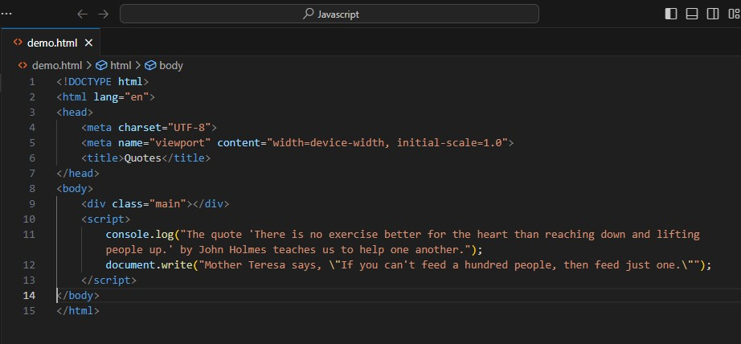

**Output:-**

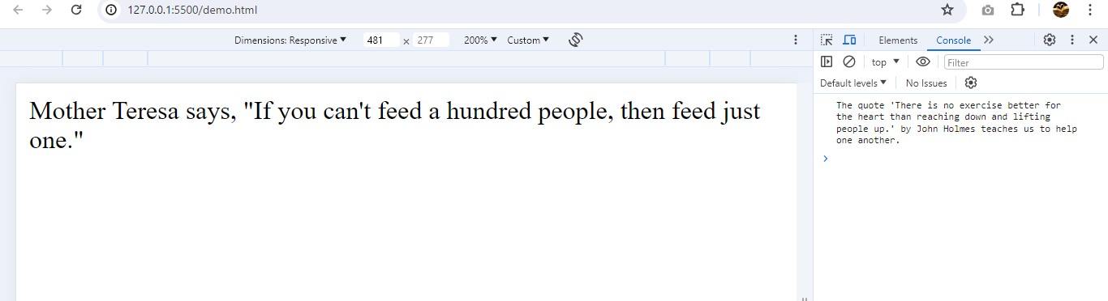

**Q.7 Check if typeof '10' is exactly equal to 10. If not make it exactly equal?**

**A.7** To check if the type of '10' is exactly equal to the type of 10, and to make them exactly equal if they are not, you can follow these steps in JavaScript:

1. Compare the types and values.
2. Convert the string '10' to a number if necessary.
3. Ensure that they are exactly equal in both value and type.

Here is the JavaScript code to achieve this:

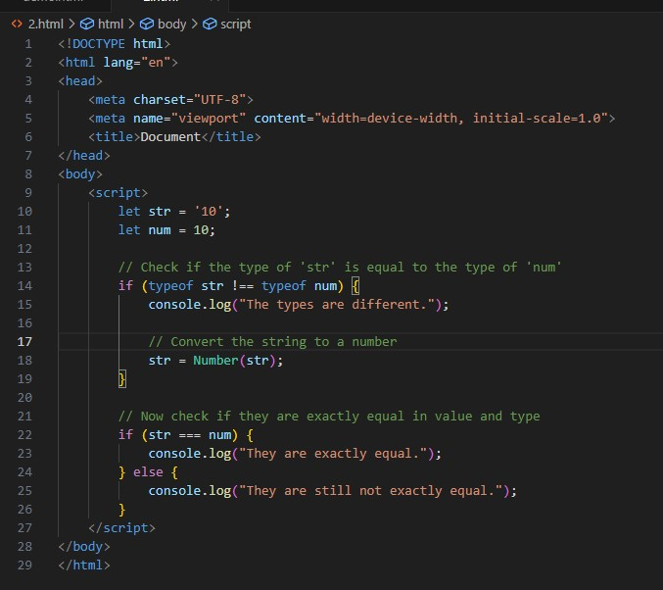

**Output:-** 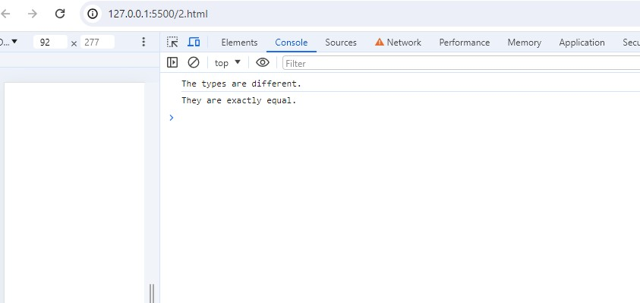

**Q.8 Write a JavaScript Program to find the area of a triangle?**

**A.8** We can use the formula for the area of a triangle:

**Area=12×base×heightArea=21​×base×height**

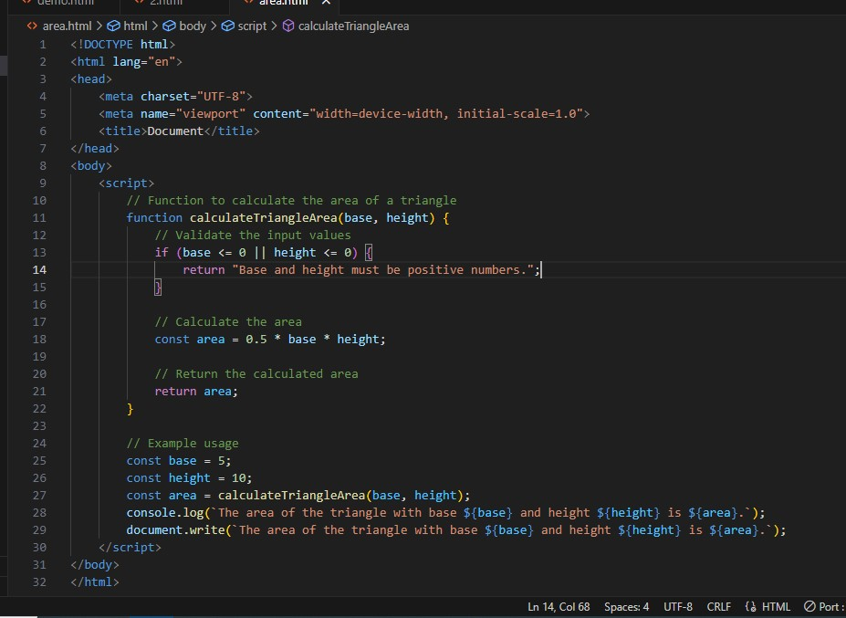

**Output:-** 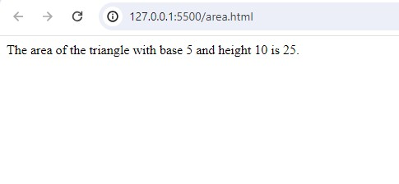

**Q.9 Write a JavaScript program to calculate days left until next Christmas?**

**A.9** Here is a JavaScript program to calculate the number of days left until the next Christmas:

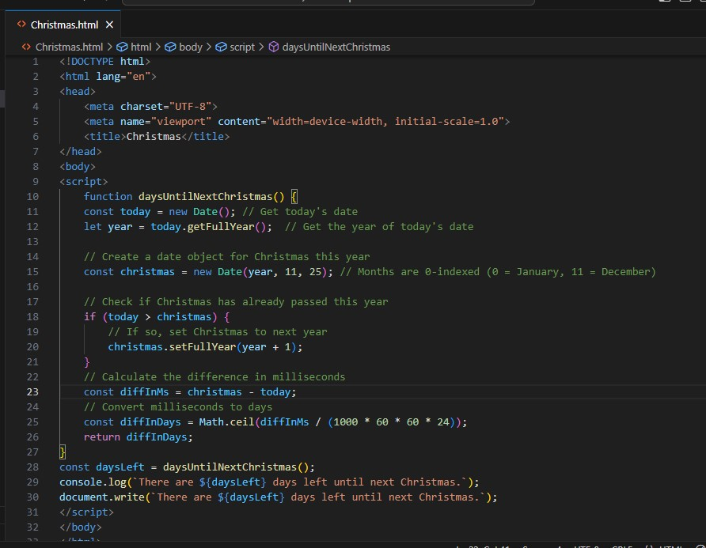

**Output:-** 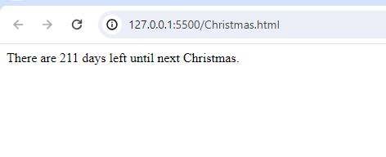

**Q.10 What is Condition Statement?**

**A.10** Conditional statements in programming are used to**control the flow of a program** based on certain conditions. These statements allow the execution of different code blocks depending on whether a specified condition evaluates to true or false, providing a fundamental mechanism for**decision-making**in algorithms. In this article, we will learn about the basics of Conditional Statements along with their different types.

**Q.11 Find circumference of Rectangle formula : C = 4 * a ?**

**A.11** 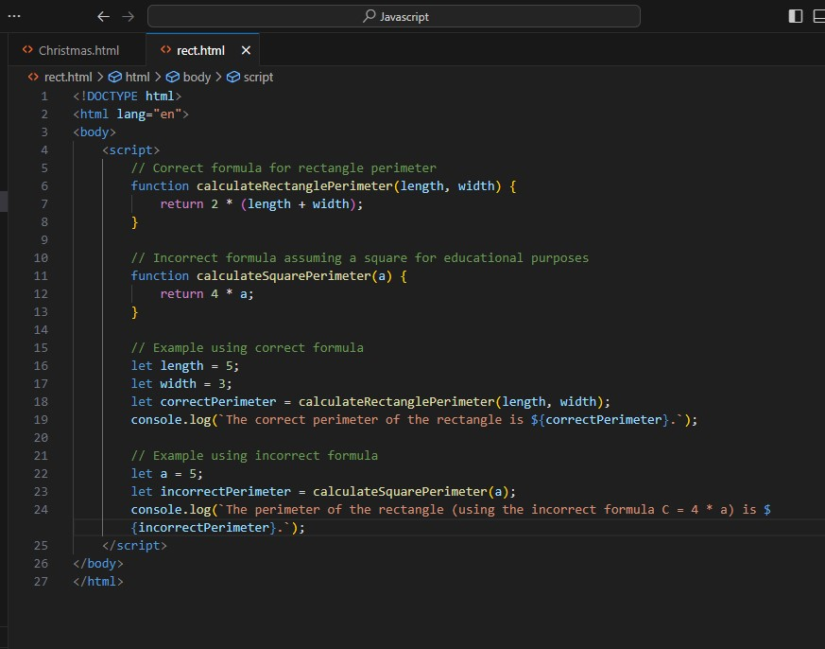

**Output:-**

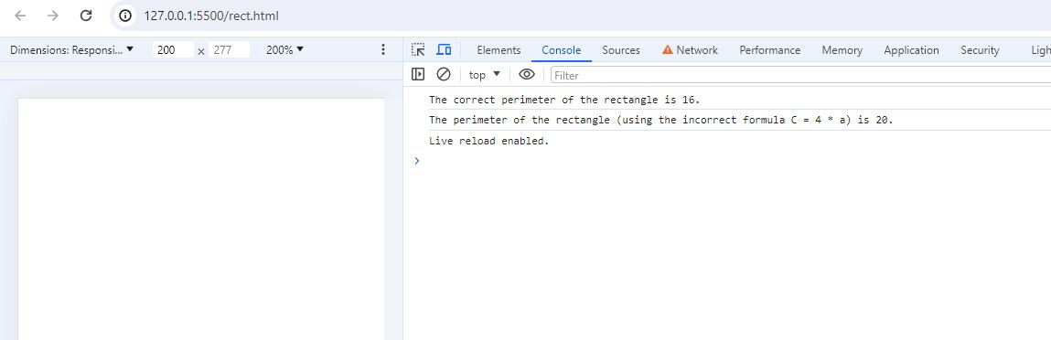

**Q.12 WAP to convert years into days and days into years?**

**A.12 Convert Years to Days :-** To convert years to days, you multiply the number of years by 365 (assuming a non-leap year).

For leap years, you could consider an average of 365.25 days per year to account for the extra day every four years.

**Convert Days to Years :-** To convert days to years, you divide the number of days by 365.

**Output:-**

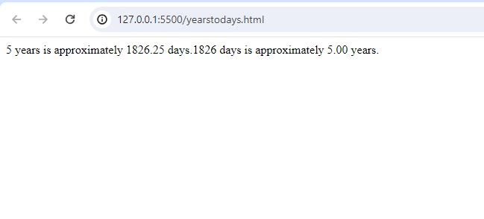

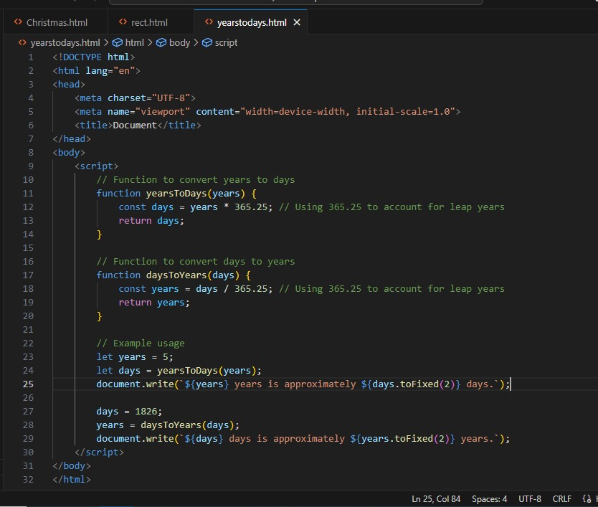

**Q.13 Convert temperature Fahrenheit to Celsius? (Conditional logic Question)**

**A.13** To convert temperature from Fahrenheit to Celsius, we can use the following formula:

𝐶=59×(𝐹−32)*C*=95​×(*F*−32)

Where:

𝐶*C* is the temperature in Celsius,

𝐹*F* is the temperature in Fahrenheit.

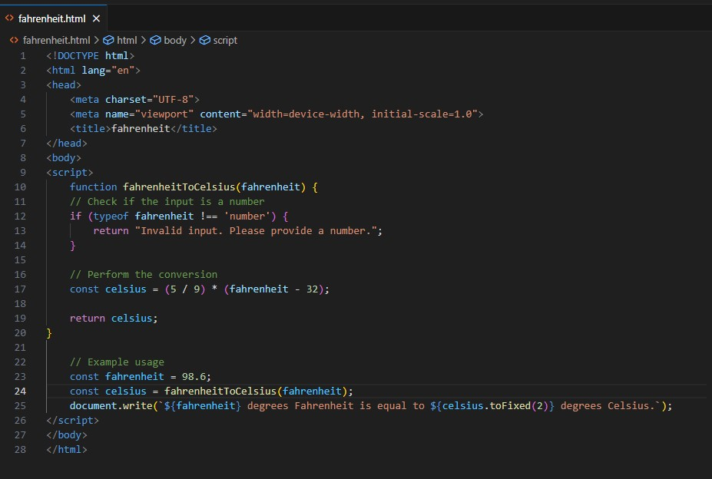

**Output:-**

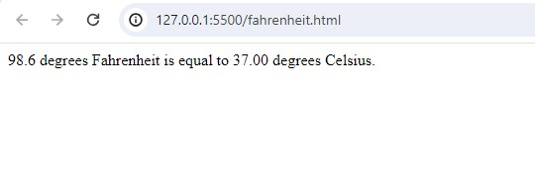

**Q.14 Write a JavaScript exercise to get the extension of a filename.?**

**A.14**

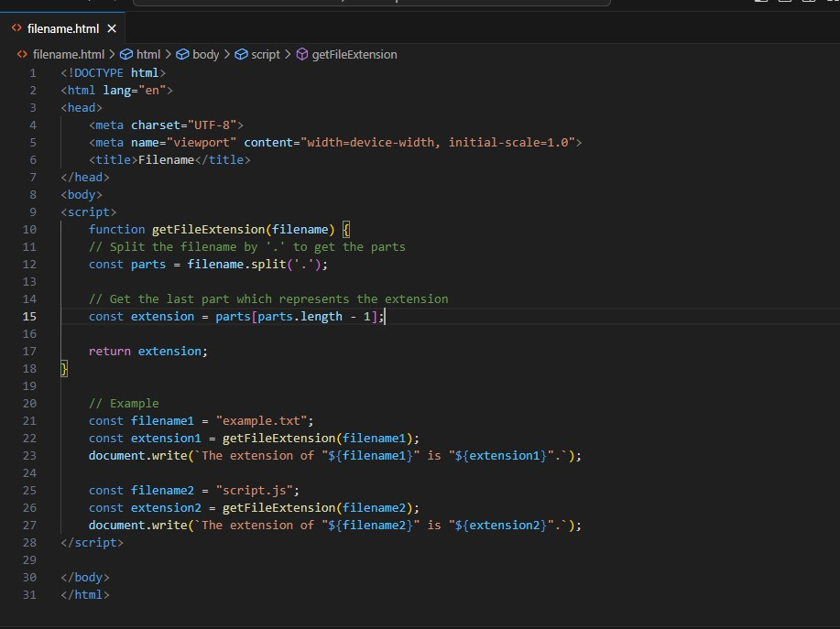

**Output:-**

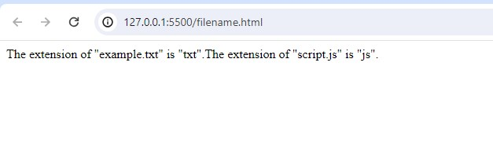

**Q.15 What is the result of the expression (5 > 3 && 2 < 4)?**

**A.15** Let's evaluate the expression (5 > 3 && 2 < 4) step by step:

* 5 > 3: This evaluates to true because 5 is greater than 3.
* 2 < 4: This evaluates to true because 2 is less than 4.

Combining them with the logical AND operator (&&), since both conditions are true, the result is true.

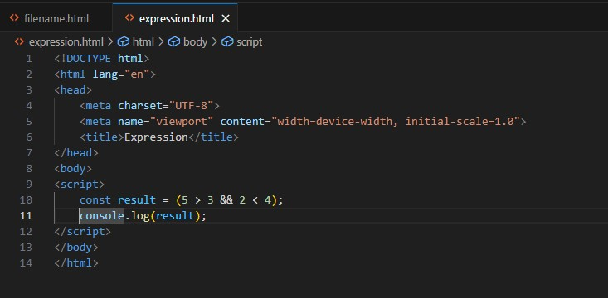

**Output:-**

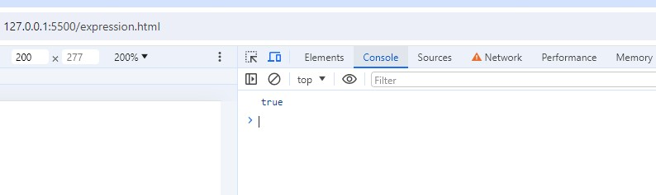

**Q.16 What is the result of the expression (true && 1 && "hello")?**

**A.16** Let's evaluate the expression (true && 1 && "hello") step by step:

true: This evaluates to true because it's a boolean value.

1: This evaluates to true because any non-zero number in JavaScript is considered truthy.

"hello": This evaluates to true because a non-empty string in JavaScript is considered truthy.

Since all operands are truthy, the && operator returns the last truthy value, which is "hello".

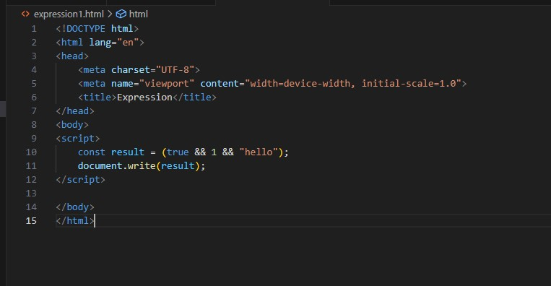

**Output:-**

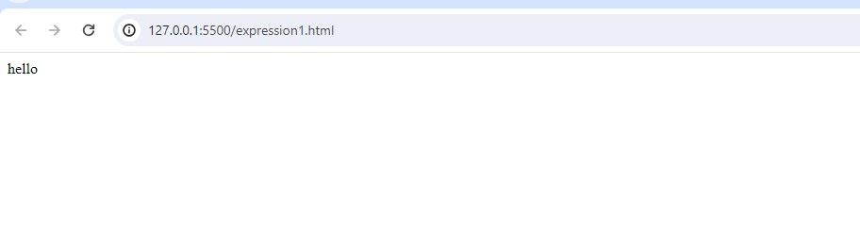

**Q.17 What is the result of the expression true && false || false && true?**

**A.17** let's evaluate the expression step by step:

true && false: This evaluates to false because one of the operands is false.

false && true: This also evaluates to false because one of the operands is false.

Finally, false || false: This evaluates to false because both operands are false.

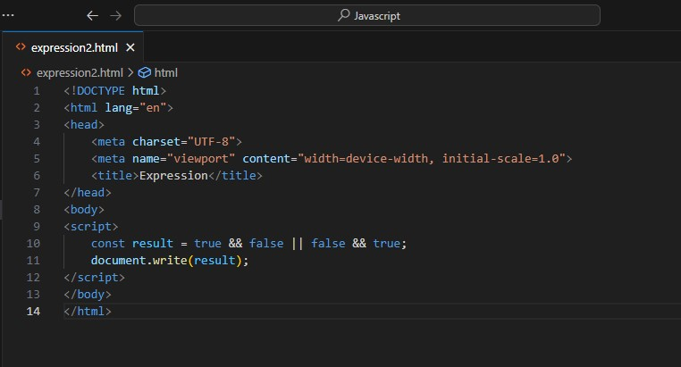

**Output:-**

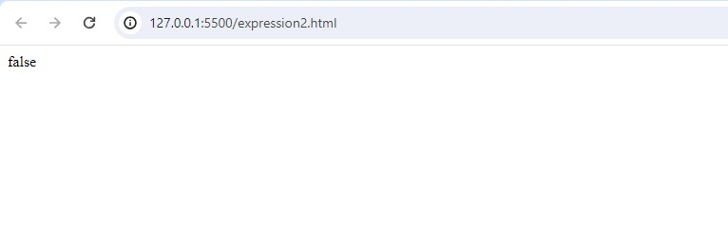**Q.18 What is a Loop and Switch Case in JavaScript define that ?**

**A.18**  A loop is a control structure that allows you to repeat a block of code multiple times. JavaScript supports several types of loops, including for,while and do…while loops. Each loop type has its own use case and syntax.

1. **For Loop**: Used when you know how many times you want to execute a statement or a block of statements.
2. **While loop**: Repeats a block of code as long as a specified condition is true.
3. **do...while loop**: Executes a block of code once, and then repeats the loop as long as a specified condition is true.

Switch Case in JavaScript

The switch statement is used to perform different actions based on different conditions. It's a more readable alternative to using multiple if...else if...else statements when you have to compare the same expression against multiple values.

**Syntax:-**

switch(expression) {  
  case x:  
    *// code block*    break;  
  case y:  
    *// code block*    break;  
  default:  
    // code block  
}

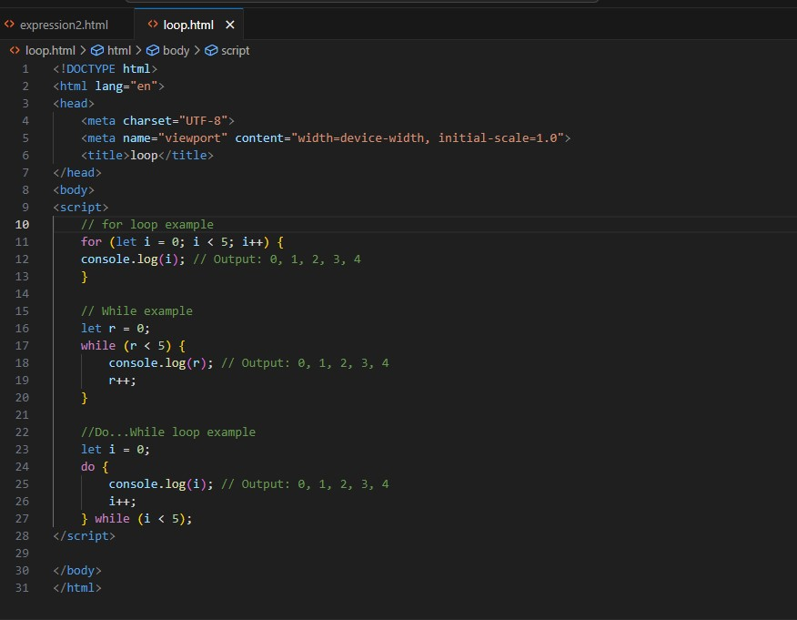

**Q.19 What is the use of is Nan function?**

**A.19** The isNaN function in JavaScript is used to determine whether a value is NaN (Not-a-Number). NaN is a special value in JavaScript that represents a value that is not a legal number.

Syntax :- isNaN( value )

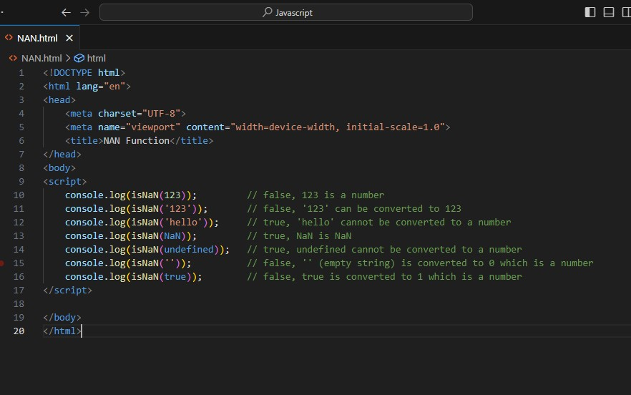

**Output:-**

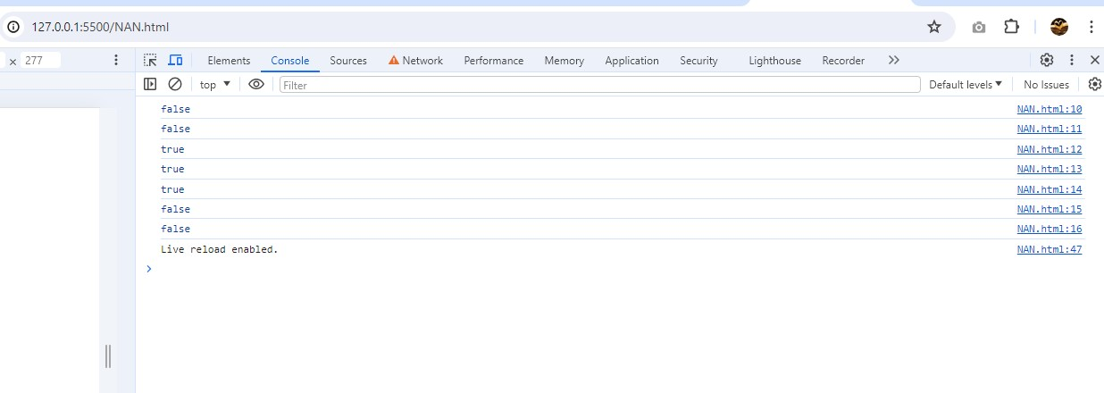

**Q.20 What is the difference between && and || in JavaScript?**

**A.20** The && operator returns true if both operands are true, otherwise, it returns false.

It evaluates from left to right and stops as soon as it encounters the first false operand, because further evaluation is unnecessary for the result to be false.

true && true;

true && false;

false && true;

false && false;

The || operator returns true if at least one of the operands is true, otherwise, it returns false.

It also evaluates from left to right and stops as soon as it encounters the first true operand, because further evaluation is unnecessary for the result to be true.

true || true;

true || false;

false || true;

false || false;

**Q.21 What is the use of Void (0)?**

**A.21** The void operator is used to evaluate an expression and returns the undefined.

This operator is used for obtaining the undefined primitive value.

It is often used with hyperlinks.

Usually the browser refreshes the page or loads a new page on clicking a link.

The javascript:void(0) can be used when we don't want to refresh or load a new page in the browser on clicking a hyperlink.

Syntax

void expression;

**Q.22 Check Number Is Positive or Negative in JavaScript?**

**A.22**

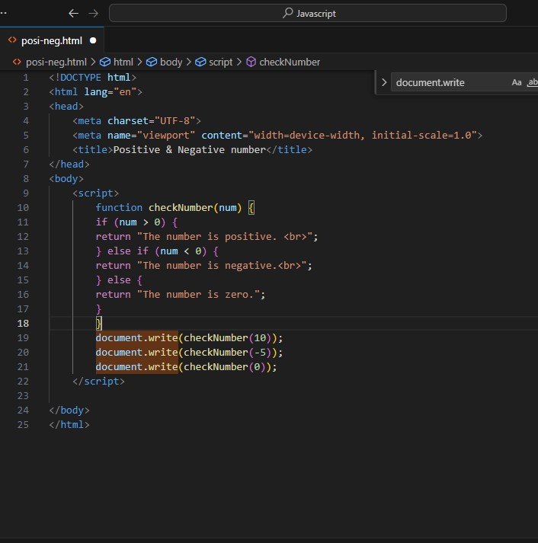

**Output:-**

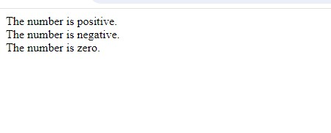

**Q.23 Find the Character Is Vowel or Not ?**

**A.23**

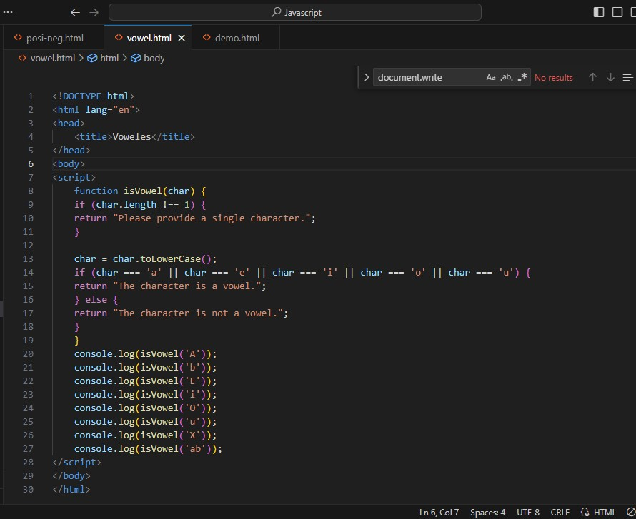**Output:-**

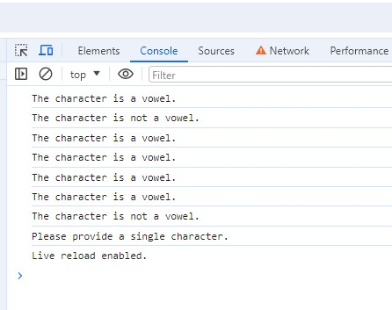

**Q.24 Write to check whether a number is negative, positive or zero?**

**A.24**

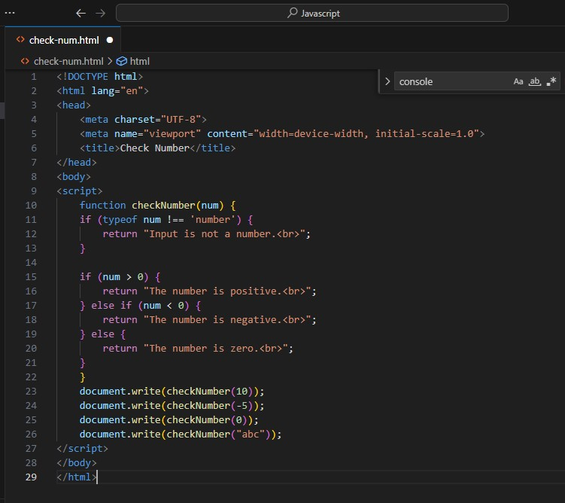

**Output:-**

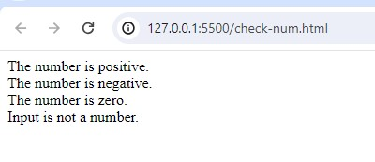

**Q.25 Write to find number is even or odd using ternary operator in JS?**

**A.25** 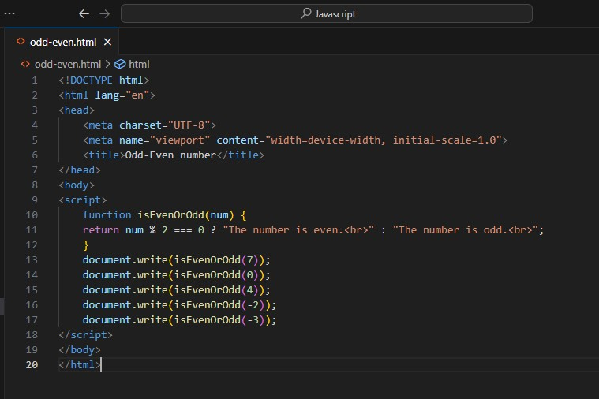

**Output:-**

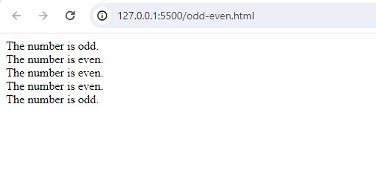

**Q.26 Write find maximum number among 3 numbers using ternary operator in JS?**

**A.26**

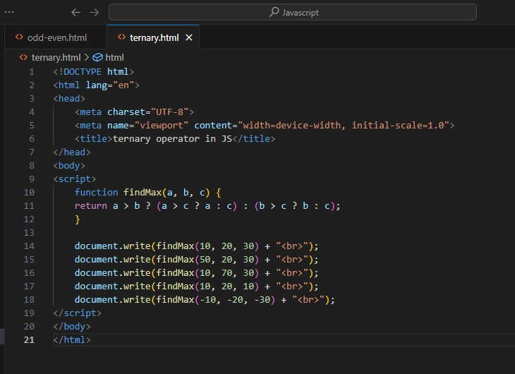

**Output:-**

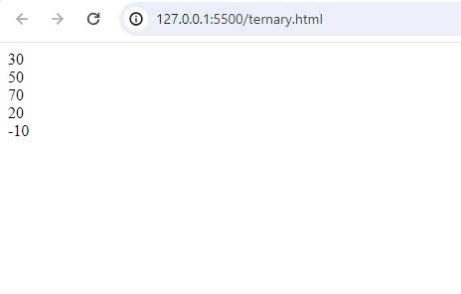

**Q.27 Write to find minimum number among 3 numbers using ternary operator in JS?**

**A.27**

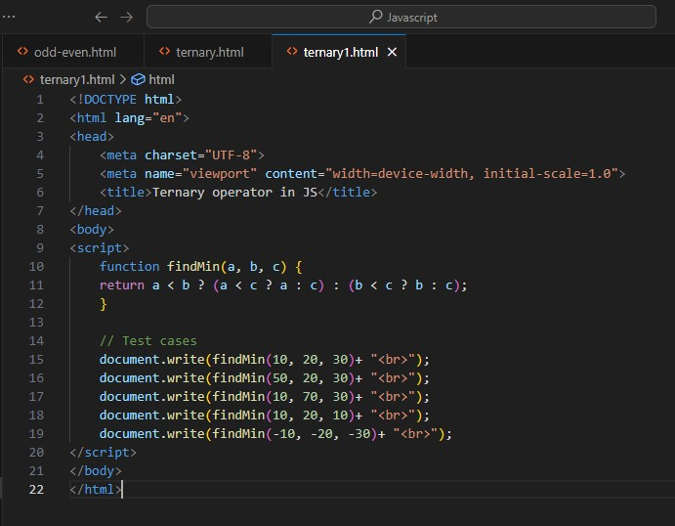

**Output:-**

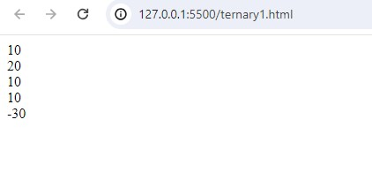

**Q.28 Write to find the largest of three numbers in JS?**

**A.28**

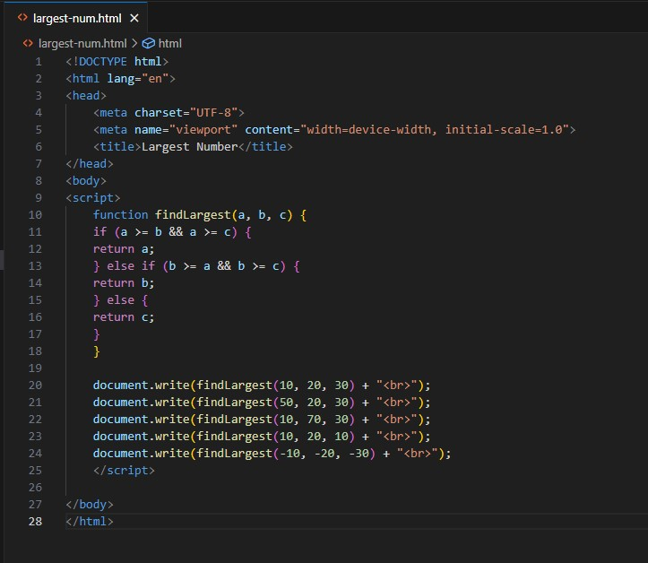

**Output:-**

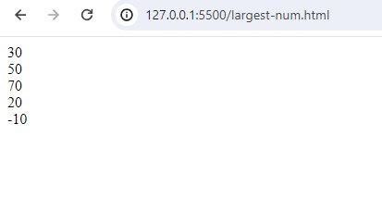

**Q.29 Write to show i. Monday to Sunday using switch case in JS? ii. Vowel or Consonant using switch case in JS?**

**A.29** i. Monday to Sunday using switch case in JS

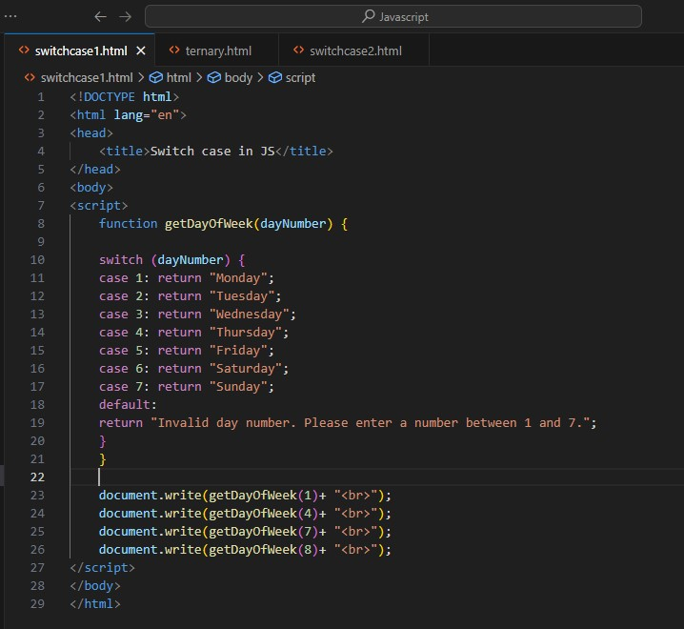

**Output:-**

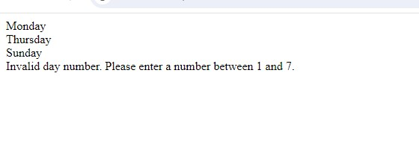

ii. Vowel or Consonant using switch case in JS

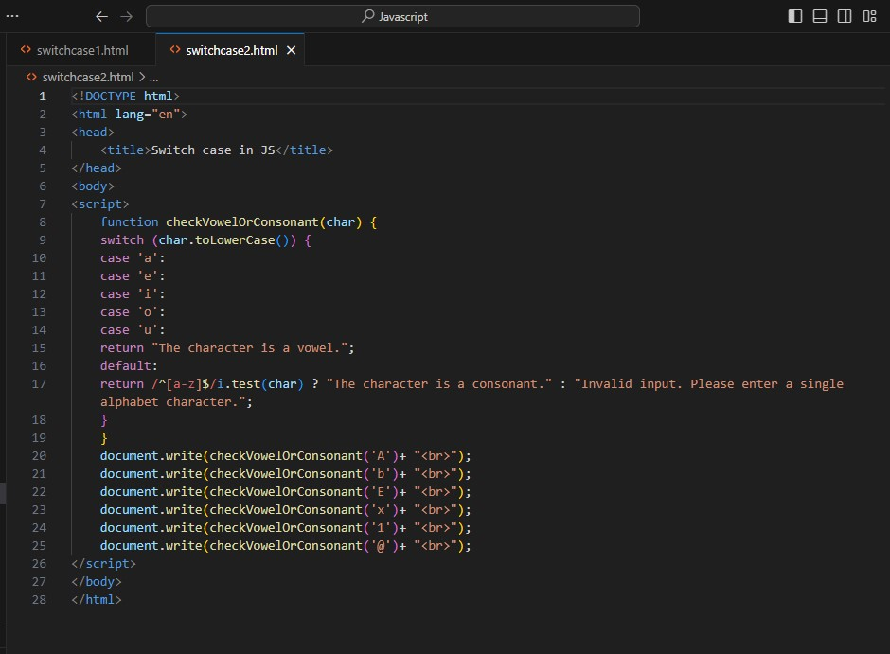

**Output:-**

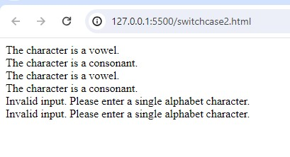

**(Conditional looping logic Question)**

**Q.30 What are the looping structures in JavaScript? Any one Example?**

**A.30** In JavaScript, there are several looping structures you can use to repeat code execution. The main looping structures are:

**for loop**: Executes a block of code a specified number of times.

**while loop**: Executes a block of code as long as a specified condition is true.

**do...while loop**: Similar to a while loop, but the code block is executed at least once before the condition is tested.

**for...in loop**: Iterates over the enumerable properties of an object.

**for...of loop**: Iterates over iterable objects such as arrays, strings, maps, sets, etc.

Here's an example of a simple for loop that iterates from 1 to 5 and prints the current value:

For ( let i = 1; i <= 5; i++ ){

Document.write(i);

}

output:- 1

2

3

4

5

**Q.31 Write a print 972 to 897 using for loop in JS?**

**A.31**

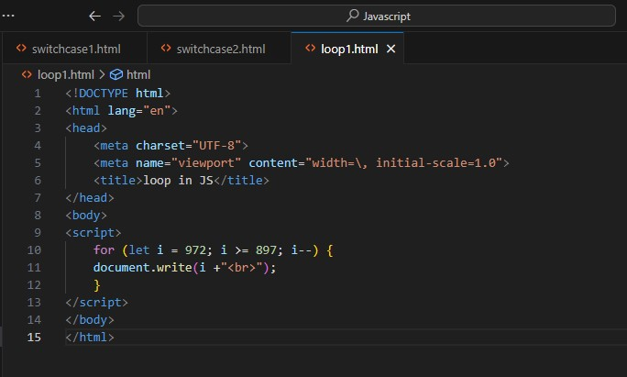

**Output:-**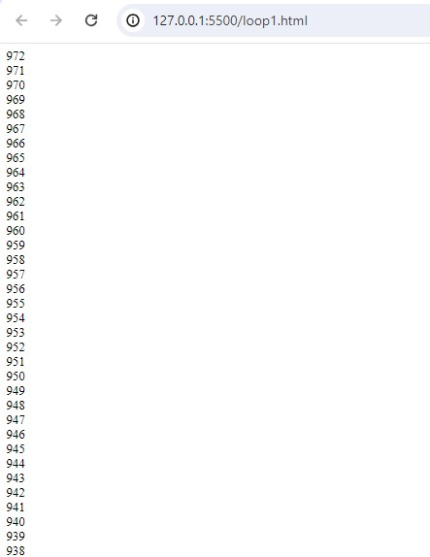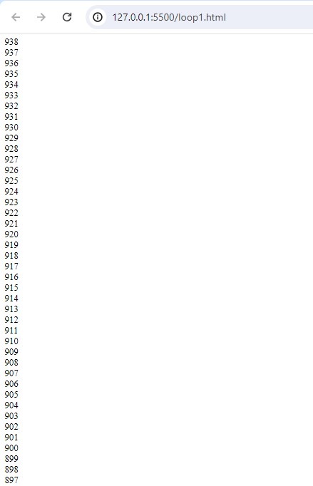

**Q.32 Write to print factorial of given number?**

**A.32**

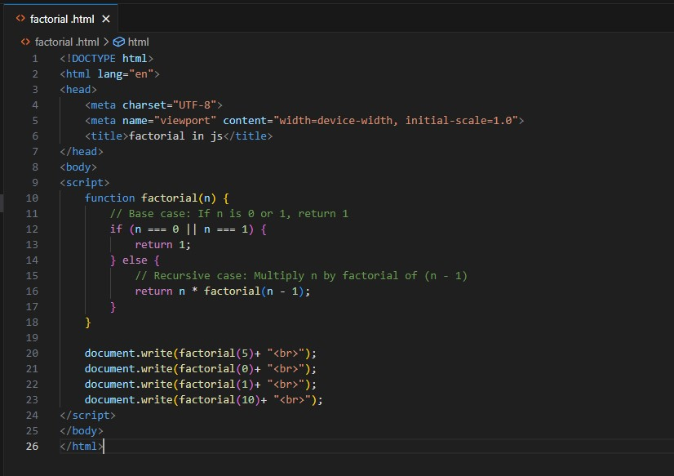

**Output:-**

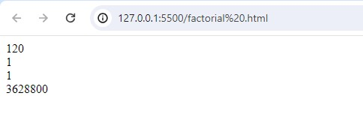

**Q.33 Write to print Fibonacci series up to given numbers?**

**A.33**

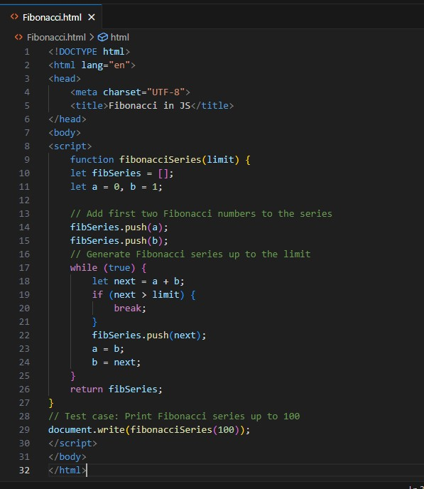

**Output:-**

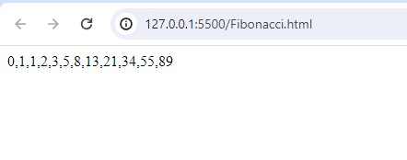

**Q.34 Write to print number in reverse order e.g.: number = 64728 ---> reverse =82746 in JS?**

**A.34**

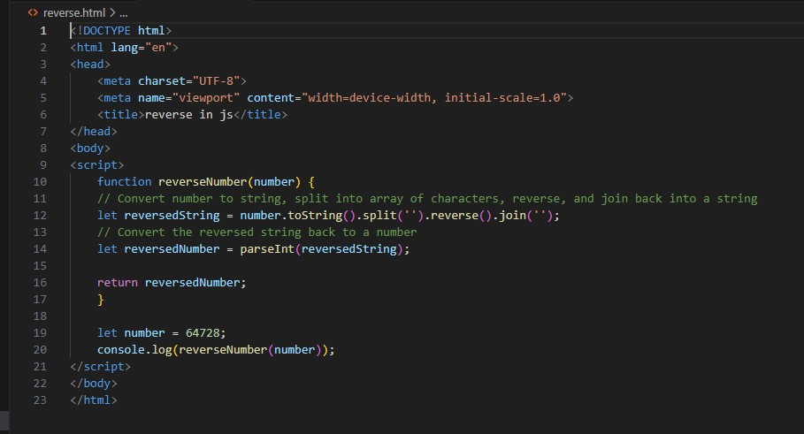

**Output:-**

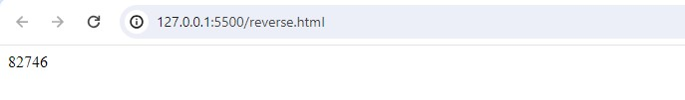

**Q.35 Write a program make a summation of given number (E.g., 1523 Ans: - 11) in JS?**

**A.35**

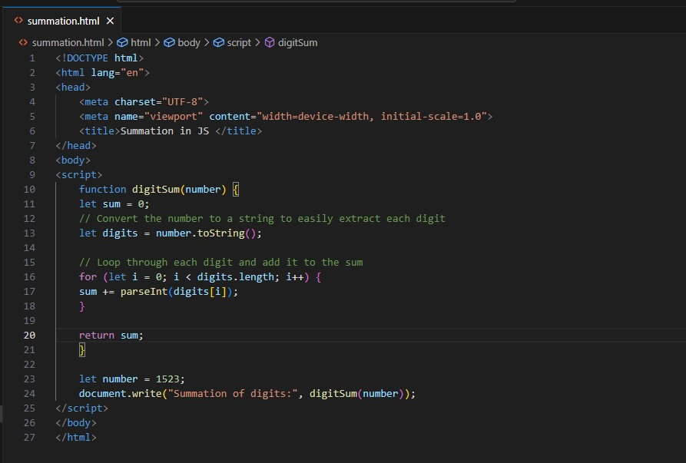

**Output:-**

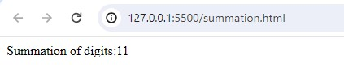

**Q.36 Write a program you have to make a summation of first and last Digit. (E.g., 1234 Ans: - 5) in JS?**

**A.36**

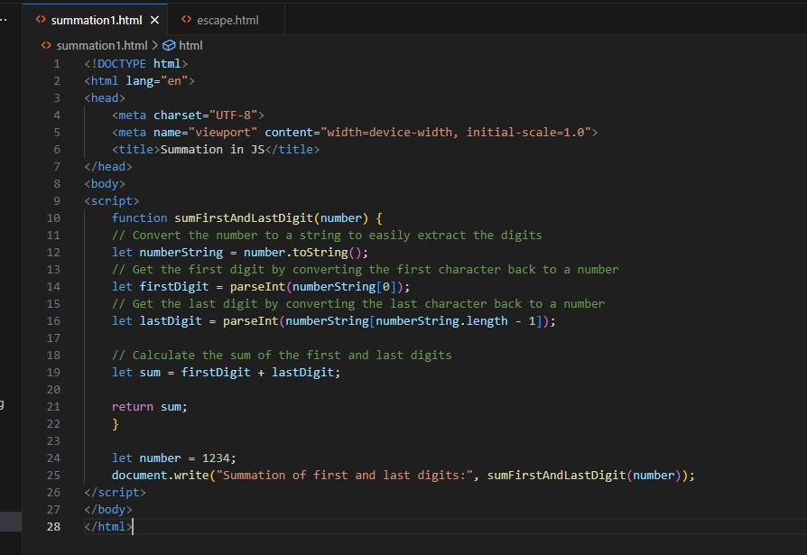

**Output:-**

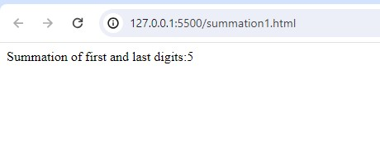

**Q.37 Use console.log() and escape characters to print the following pattern in JS?**

# **1 1 1 1 1**

# **2 1 2 4 8**

# **3 1 3 9 27**

# **4 1 4 16 64**

# **5 1 5 25 125**

**A.37**

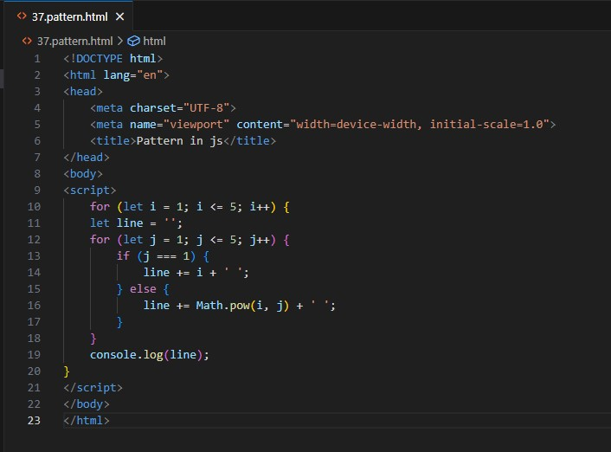

**Output:-**

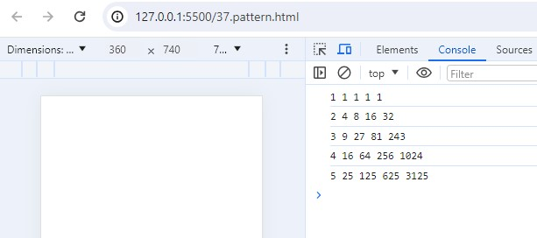

**Q.38 Use pattern in console.log in JS?**

**A.38**

**1) 1**

**1 0**

**1 0 1**

**1 0 1 0**

**1 0 1 0 1**

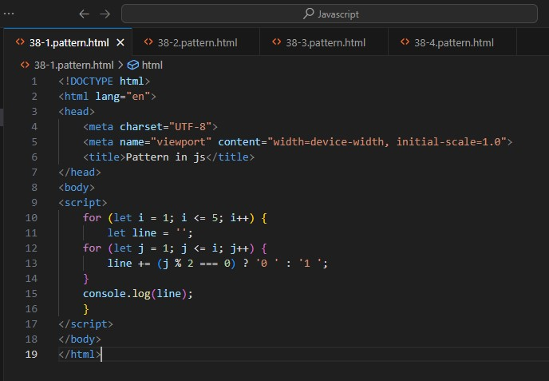

**2) A**

# **B C**

# **D E F**

# **G H I J**

# **K L M N O**

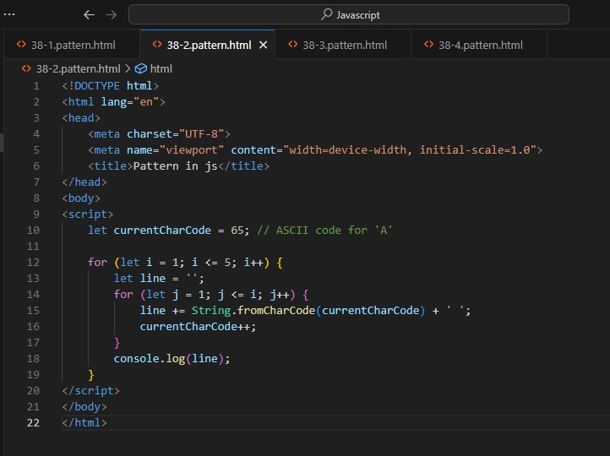

**3) 1**

**2 3**

**4 5 6**

**7 8 9 10**

**11 12 13 14 15**

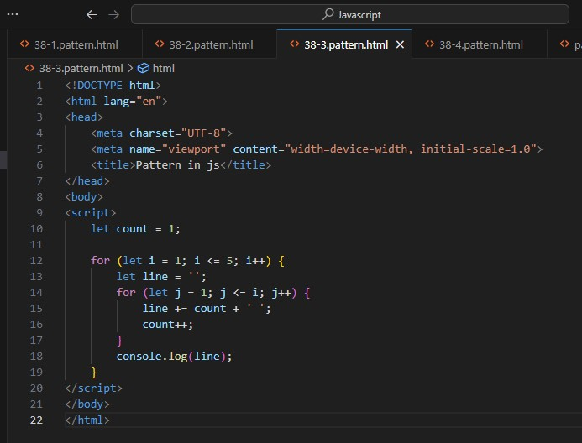

**4)**

**\***

**\* \***

**\* * \***

**\* * * \***

**\* * * * \***

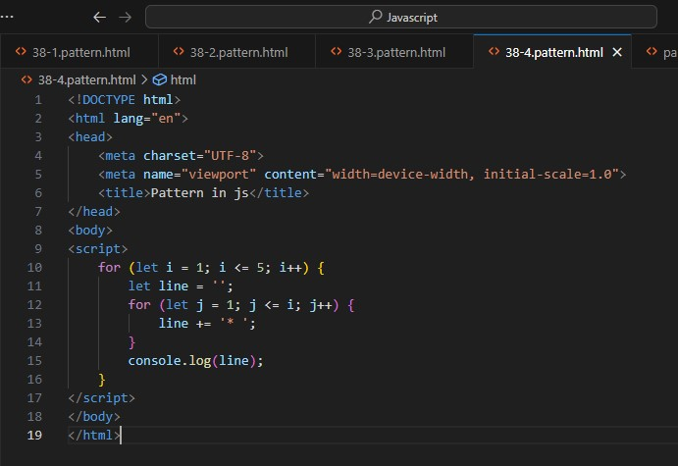

**Q.39 Accept 3 numbers from user using while loop and check each numbers palindrome?**

**A.39**

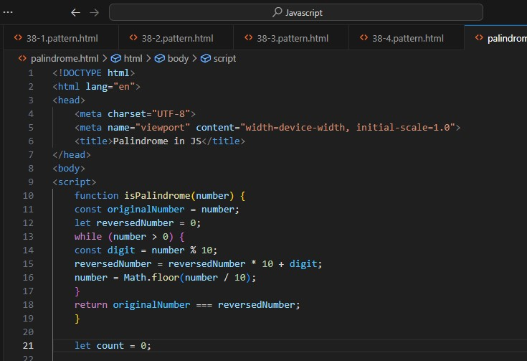

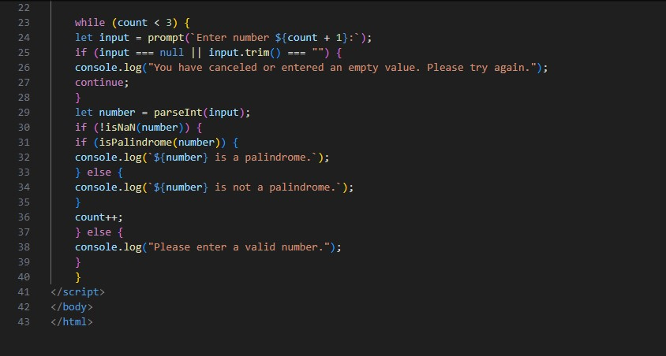

**Output:-**

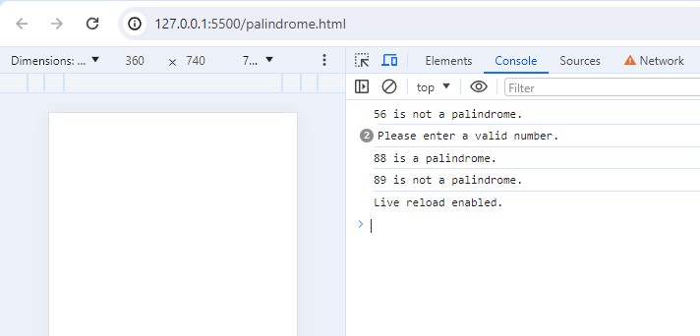

**(Array and object Question)**

**Q.40 Write a JavaScript Program to display the current day and time in the following format. Sample Output: Today is Friday. Current Time is 12 PM: 12 : 22 2 ?**

**A.40**

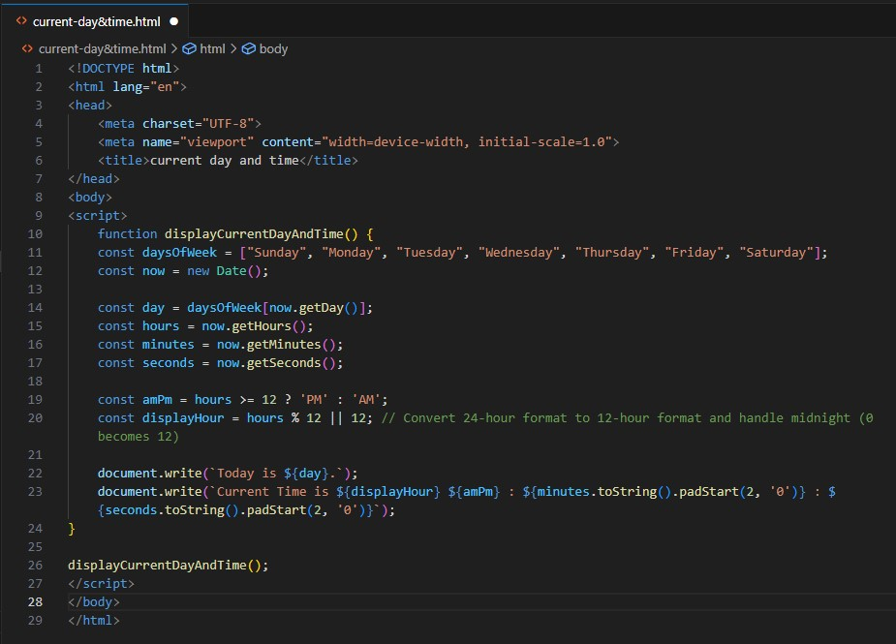

**Output:-**

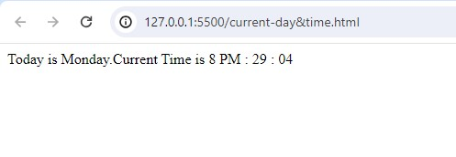

**Q.41 Write a JavaScript program to get the current date?**

**A.41**

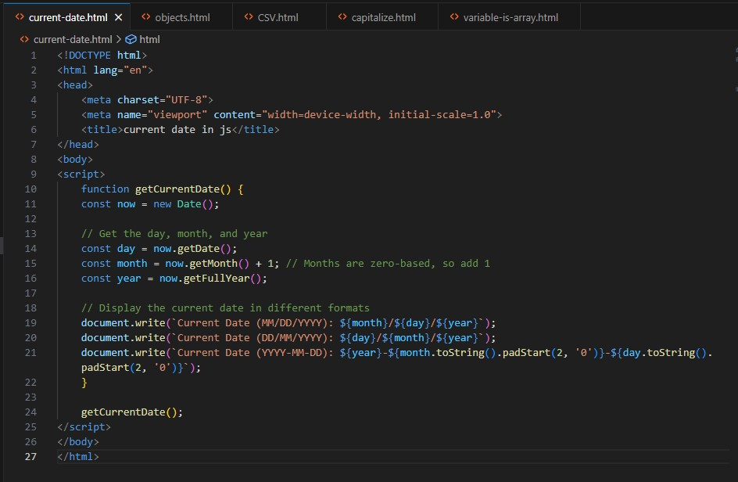

**Output:-**

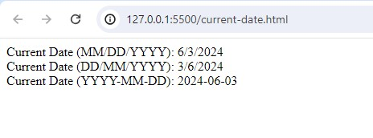

**Q.42 Write a JavaScript program to compare two objects?**

**A.42**

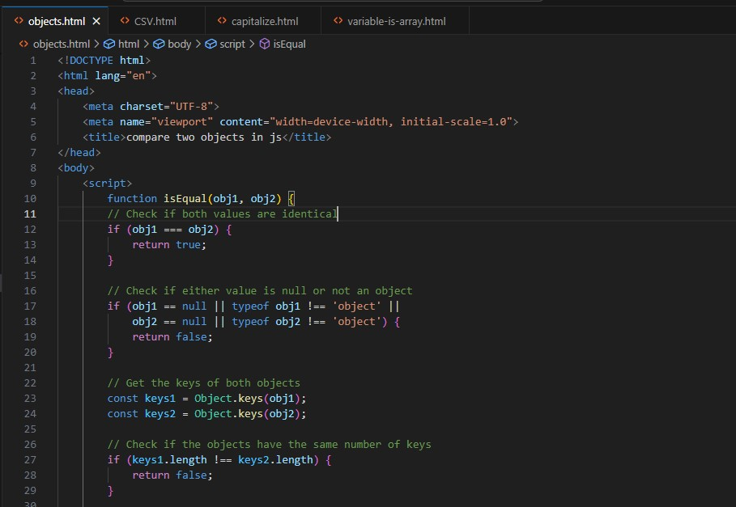

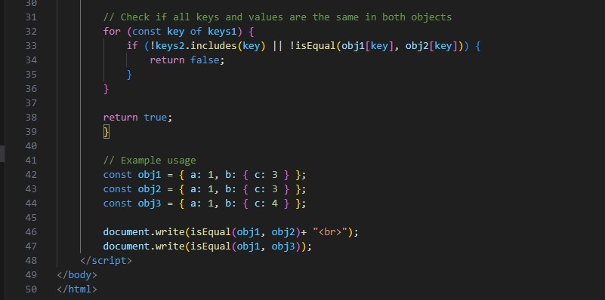

**Output:-**

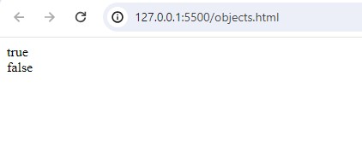

**Q.43 Write a JavaScript program to convert an array of objects into CSV string?**

**A.43**

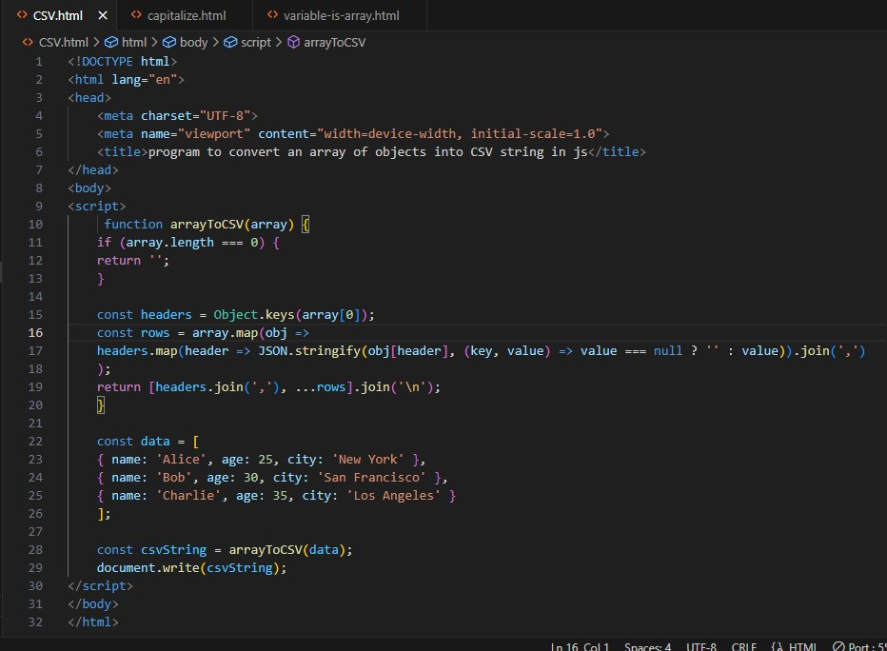

**Output:-**

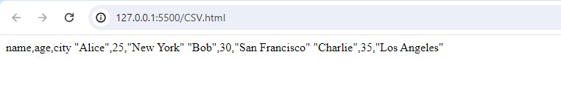**Q.44 Write a JavaScript program to capitalize first letter of a string?**

**A.44**

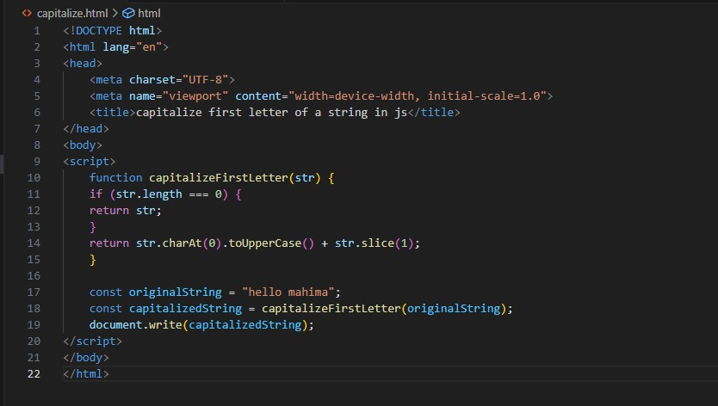

**Output:-**

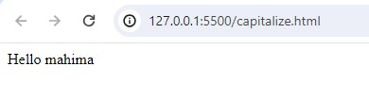

**Q. 45 Write a JavaScript program to determine if a variable is array?**

**A.45**

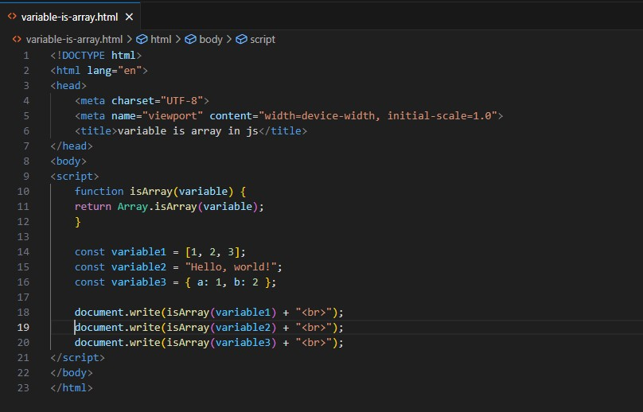

**Output:-**

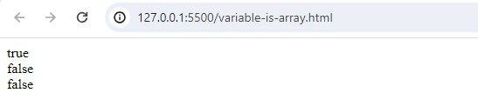

**Q.46 Write a JavaScript program to clone an array?**

**A.46**

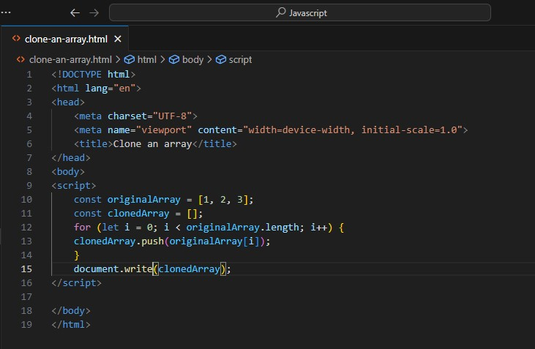

**Output:-**

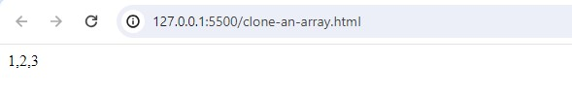

**Q.47 What is the drawback of declaring methods directly in JavaScript objects?**

**A.47** Drawback of declaring methods directly in JavaScript objects

Memory Consumption

Inefficiency

Difficulties with Inheritance

Encapsulation

**Q.48 Print the length of the string on the browser console using console.log()?**

**A.48**

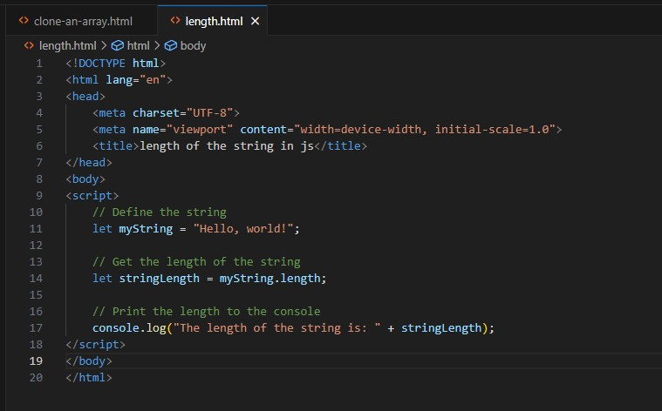

**Output:-**

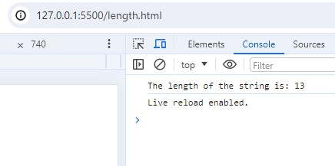

**Q.49 Change all the string characters to capital letters using toUpperCase() method?**

**A.49**

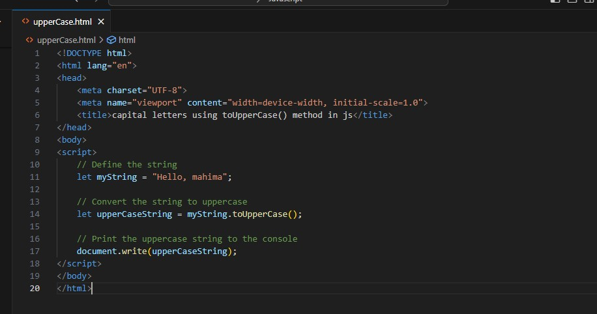

**Output:-**

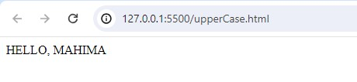

**Q.50 What is the drawback of declaring methods directly in JavaScript objects?**

**A.50** Drawback of declaring methods directly in JavaScript objects

Memory Consumption

Inefficiency

Difficulties with Inheritance

Encapsulation

**Q.51 Write a JavaScript program to get the current date. Expected Output : mm-dd-yyyy, mm/dd/yyyy or dd-mm-yyyy, dd/mm/yyyy?**

**A.51**

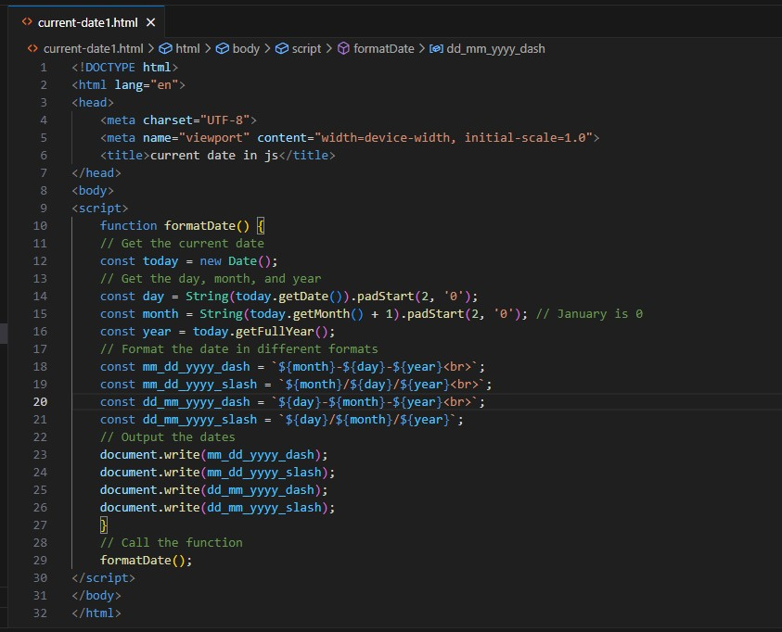

**Output:-**

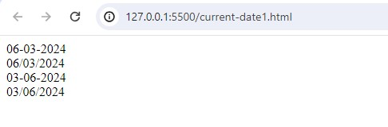

**Q.52 Use indexOf to determine the position of the first occurrence of a in 30 Days Of JavaScript?**

**A.52**

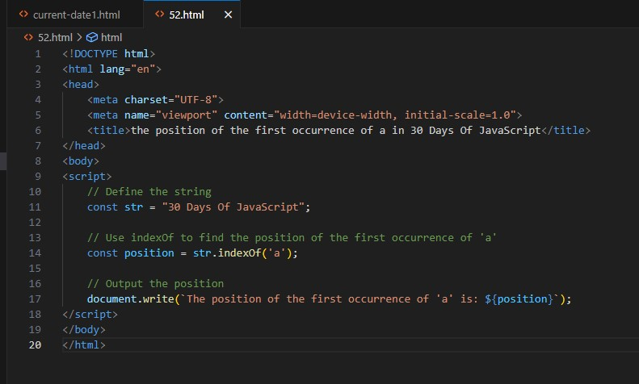

**Output:-**

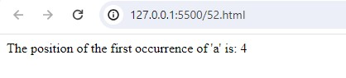

**Q.53 Use lastIndexOf to determine the position of the last occurrence of a in 30 Days Of JavaScript?**

**A.53**

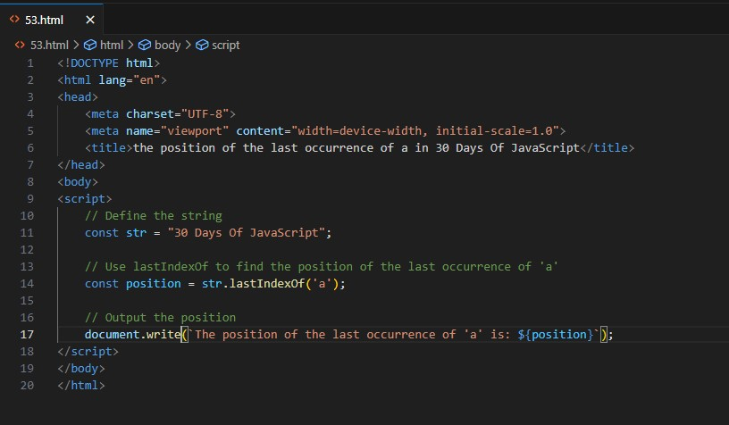

**Output:-**

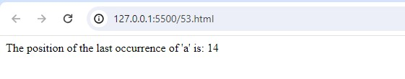

**Q.54 Form Validtion in JS?**

**A.54**

**Output:-**

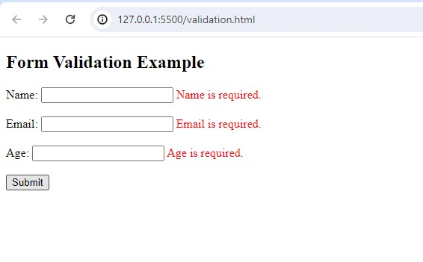

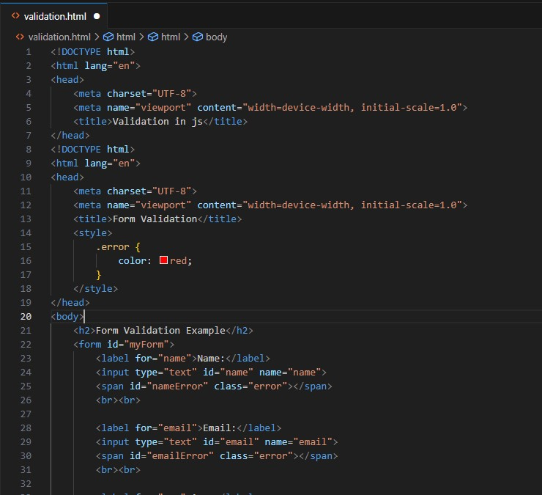

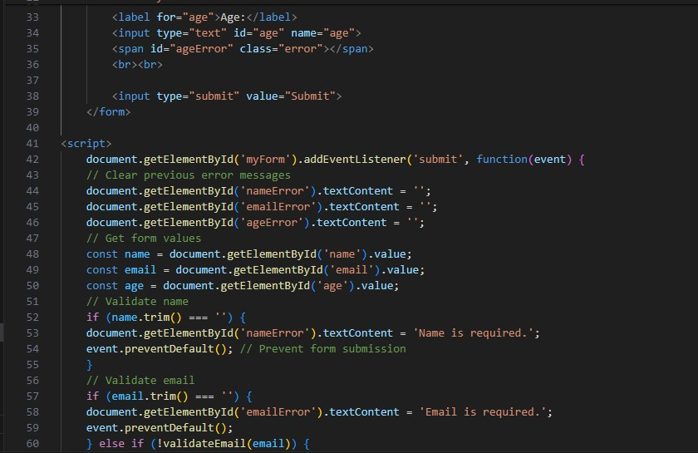

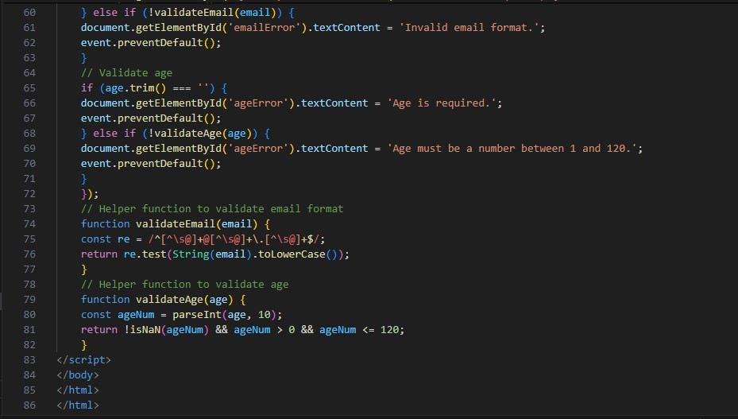

**Q.55 Form in Email, number, Password, Validation?**

**A.55 Output:-**

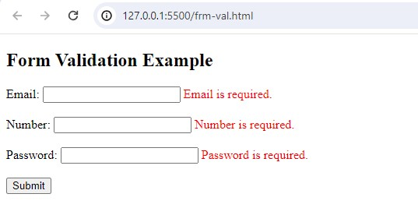

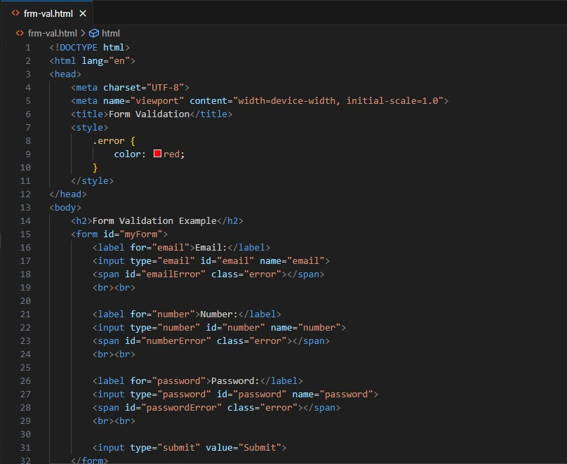

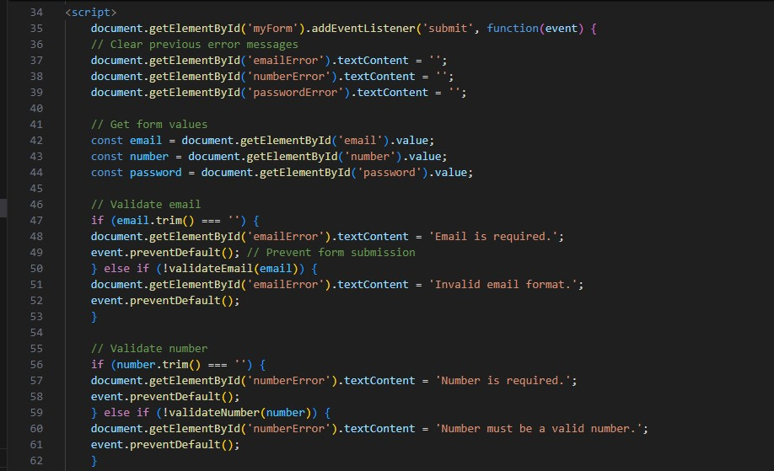

**Q.56 Dynamic Form Validation in JS?**

**A.56** Dynamic form validation in JavaScript is about providing real-time feedback to users as they interact with form fields.

This makes forms more user-friendly and helps prevent submission of invalid data.

**Q.57 how many type of JS Event? How to use it ?**

**A.57** 1.onchange = An HTML element has been changed

<button onchange ="document.getElementById('demo').innerHTML = Date()">The time is?</button>

2.onclick = The user clicks an HTML element

<button onclick="document.getElementById('demo').innerHTML = Date()">The time is?</button>

3.onmouseover = The user moves the mouse over an HTML element

<button onmouseover ="document.getElementById('demo').innerHTML = Date()">The time is?</button>

4.onmouseout=The user moves the mouse away from an HTML element

<button onmouseout ="document.getElementById('demo').innerHTML = Date()">The time is?</button>

5.onkeydown = The user pushes a keyboard key

<button onkeydown ="document.getElementById('demo').innerHTML = Date()">The time is?</button>

6.onload = The browser has finished loading the page

<button onload ="document.getElementById('demo').innerHTML = Date()">The time is?</button>

**Q.59 What is Bom vs Dom in JS?**

**A.59** Browser Object Model (BOM) is a browser-specific convention referring to all the objects exposed by the web browser.

The BOM allows JavaScript to “interact with” the browser.

The window object represents a browser window and all its corresponding features.

A window object is created automatically by the browser itself.

Java Script’s window.screen object contains information about the user’s screen.

It can also be written without the window prefix.

Document Object Model (DOM) is a programming interface for HTML and XML documents, that allows to create, manipulate, or delete the element from the document.

It defines the logical structure of documents and the way a document is accessed and manipulated.

With the help of DOM, the webpage can be represented in a structured hierarchy,

i.e., we can easily access and manipulate tags, IDs, classes, Attributes, or Elements of HTML using commands or methods provided by the Document object, that will guide the programmers and users to understand the document in an easier manner.

**Q.60 Array vs object defences in JS?**

**A.60** Arrays

Arrays are ordered collections of values, which can be accessed by their index

They are created using square brackets [] or the Array constructor.

Syntax:

let arr = [1, 2, 3, 4];

let arr2 = new Array(1, 2, 3, 4);

Each element in an array has a numerical index starting from 0.

Arrays have a length property that dynamically updates as elements are added or removed.

Objects

Objects are collections of key-value pairs, where keys (also called properties) are strings or symbols, and values can be of any data type.

They are created using curly braces {} or the Object constructor.

Syntax:

let obj = { name: "Alice", age: 25 };

let obj2 = new Object();

obj2.name = "Alice";

obj2.age = 25;

Each value is accessed using a unique key.

Properties can be added, modified, or deleted at runtime.

**Q.61 Split the string into an array using split() Method?**

**A.61** The split() method splits (divides) a string into two or more substrings depending on a splitter (or divider). The splitter can be a single character, another string, or a regular expression.

There are some methods to split the string into an array using split() method:-

Split using a space character

## Split a String by Each Character

## Split a String into One Array

## Split a String Using a Non-matching Character

# Split with a Limit

# Split Using Regex

# Replace Characters in a String using Split() Method

**Q.62 Check if the string contains a word Script using includes() method?**

**A.62**

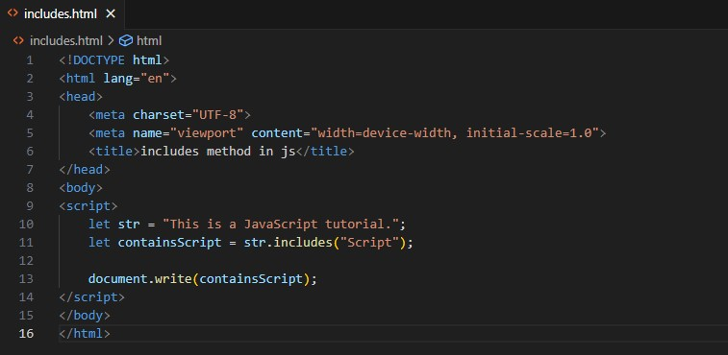

**Output:-**

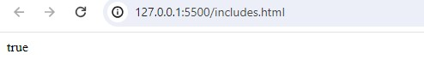

**Q.63 Change all the string characters to lowercase letters using toLowerCase() Method.**

**A.63**

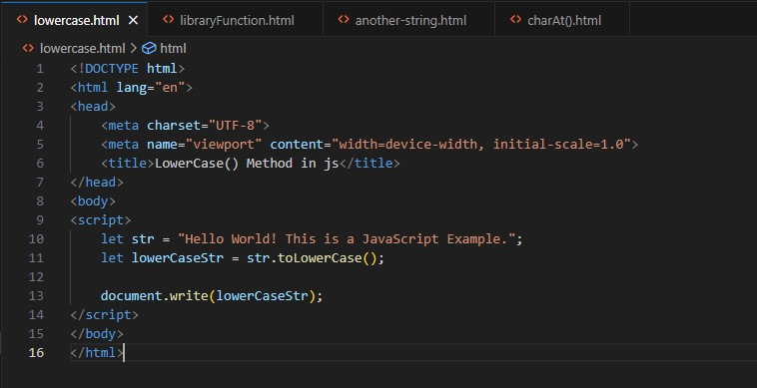

**Output:-**

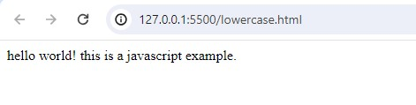

**Q.64 What is Character at index 15 in ’30 Days of JavaScript’ string? Use charAt() method.**

**A.64**

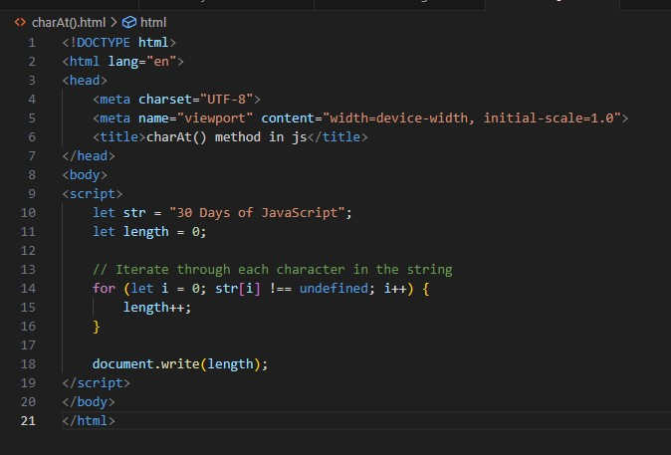

**Output:-**

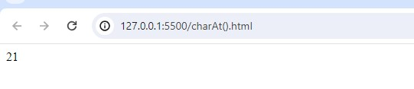

**Q.65 copy to one string to another string in JS?**

**A.65**

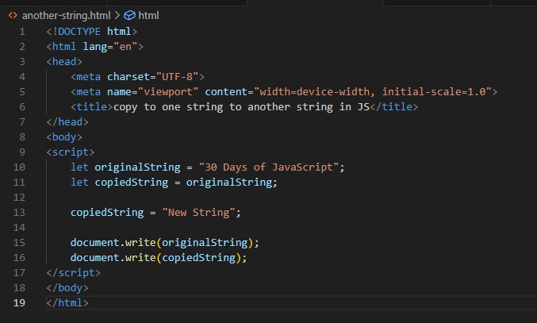

**Output:-**

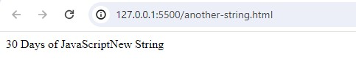

**Q.66 Find the length of a string without using libraryFunction?**

**A.66**

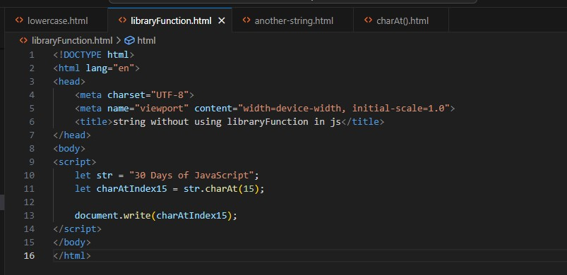

**Output:-**

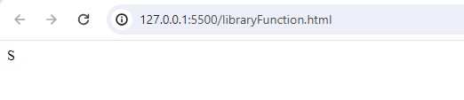

**• What is JavaScript?**

**Ans.** JavaScript is a programming language used to make web pages interactive. It can be used to create things like pop-up messages, change content dynamically, and respond to user actions like clicks and key presses.

**• What is the use of isNaN function?**

**ANS.** isNaN() method returns true if a value is Not-a-Number.

Number.isNaN() returns true if a number is Not-a-Number.

isNaN() converts the value to a number before testing it.

**• What is negative Infinity?**

**ANS.** The negative infinity in JavaScript is a constant value that is used to represent a value that is the lowest available.

* This means that no other number is lesser than this value.
* It can be generated using a self-made function or by an arithmetic operation.
* Negative infinity results in -0(different from 0 ) when divided by any other number.
* When divided by itself or positive infinity, negative infinity return NaN
* Negative infinity, when divided by any positive number (apart from positive infinity) is negative infinity.
* Negative infinity, divided by any negative number (apart from negative infinity) is positive infinity.

**• Which company developed JavaScript?**

**ANS.** JavaScript was invented by Brendan Eich in 1995.

* It was developed for Netscape 2, and became the ECMA-262 standard in 1997.
* After Netscape handed JavaScript over to ECMA, the Mozilla foundation continued to develop JavaScript for the Firefox browser.
* Mozilla's latest version was 1.8.5. (Identical to ES5).
* Internet Explorer (IE4) was the first browser to support ECMA-262 Edition 1 (ES1).

**• What are undeclared and undefined variables?**

**ANS.** Undefined: It occurs when a variable has been declared but has not been assigned any value. Undefined is not a keyword.

* let mahima;
* undefined
* console.log(mahima)
* Undeclared: It occurs when we try to access any variable that is not initialized or declared earlier using the var or const keyword.
* console.log(myVariable)
* If we use ‘typeof’ operator to get the value of an undeclared variable, we will face the runtime error with the return value as “undefined”. The scope of the undeclared variables is always global.

**• Write the code for adding new elements dynamically?**

**ANS.**

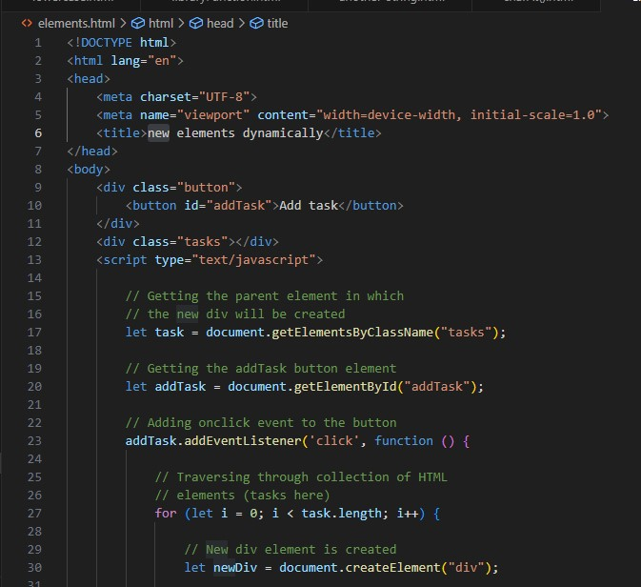

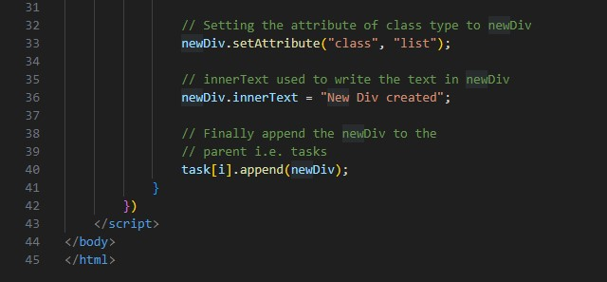

**Output:-**

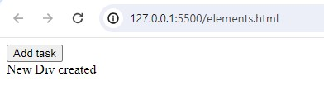

**• What is the difference between ViewState and SessionState?**

**ANS. ViewState-**

* Maintained at page level only.
* View state can only be visible from a single page and not multiple pages.
* It will retain values in the event of a postback operation occurring.
* Information is stored on the client’s end only.
* used to allow the persistence of page-instance-specific data.
* ViewState values are lost/cleared when new page is loaded.

**SessionState-**

* Maintained at session level.
* Session state value availability is across all pages available in a user session.
* In session state, user data remains in the server. Data is available to user until the browser is closed or there is session expiration.
* Information is stored on the server.
* used for the persistence of user-specific data on the server’s end.

**• What is === operator?**

**ANS.** JavaScript Strict Equality Operator is used to compare two operands and return true if both the value and type of operands are the same.

**• How can the style/class of an element be changed?**

**ANS.** There are two common approaches that allow us to achieve this task.

* style.property
* Changing the class itself

**Approach 1:**Changing CSS with the help of the style property:

**Syntax:**

document.getElementById("id").style.property = new_style

**Approach 2: Changing the class itself –**We can use two properties that can be used to manipulate the classes.

**The classList Property:**The **classList** is a read-only property that returns the CSS class names of an element as a DOMTokenList object.

**Syntax:**

document.getElementById("id").classList

**• How to read and write a file using JavaScript?**

**ANS.** On the client side, you can’t read or write files in JavaScript browsers.

read-

Syntax:

fs.readFile( file_name, encoding, callback_function )

write-

Syntax:

fs.writeFile( file_name, data, options, callback )

The fs.writeFile() function is used to write data to a file in an asynchronous manner. If the file already exists, it will be replaced.

**• What are all the looping structures in JavaScript?**

**ANS.** Loop in Javascript:- Loops in JavaScript execute a block of code again and again while the condition is true.

suppose we want to print “Hello World” 5 times. This can be done using JS Loop easily. In Loop, the statement needs to be written only once and the loop will be executed 5 times.

Types of loop:-

1.For loop

2.While loop

3.do-while loop

4.Break Statement

5.Continue Statement

**• How can you convert the string of any base to an integer in JavaScript?**

**ANS.**

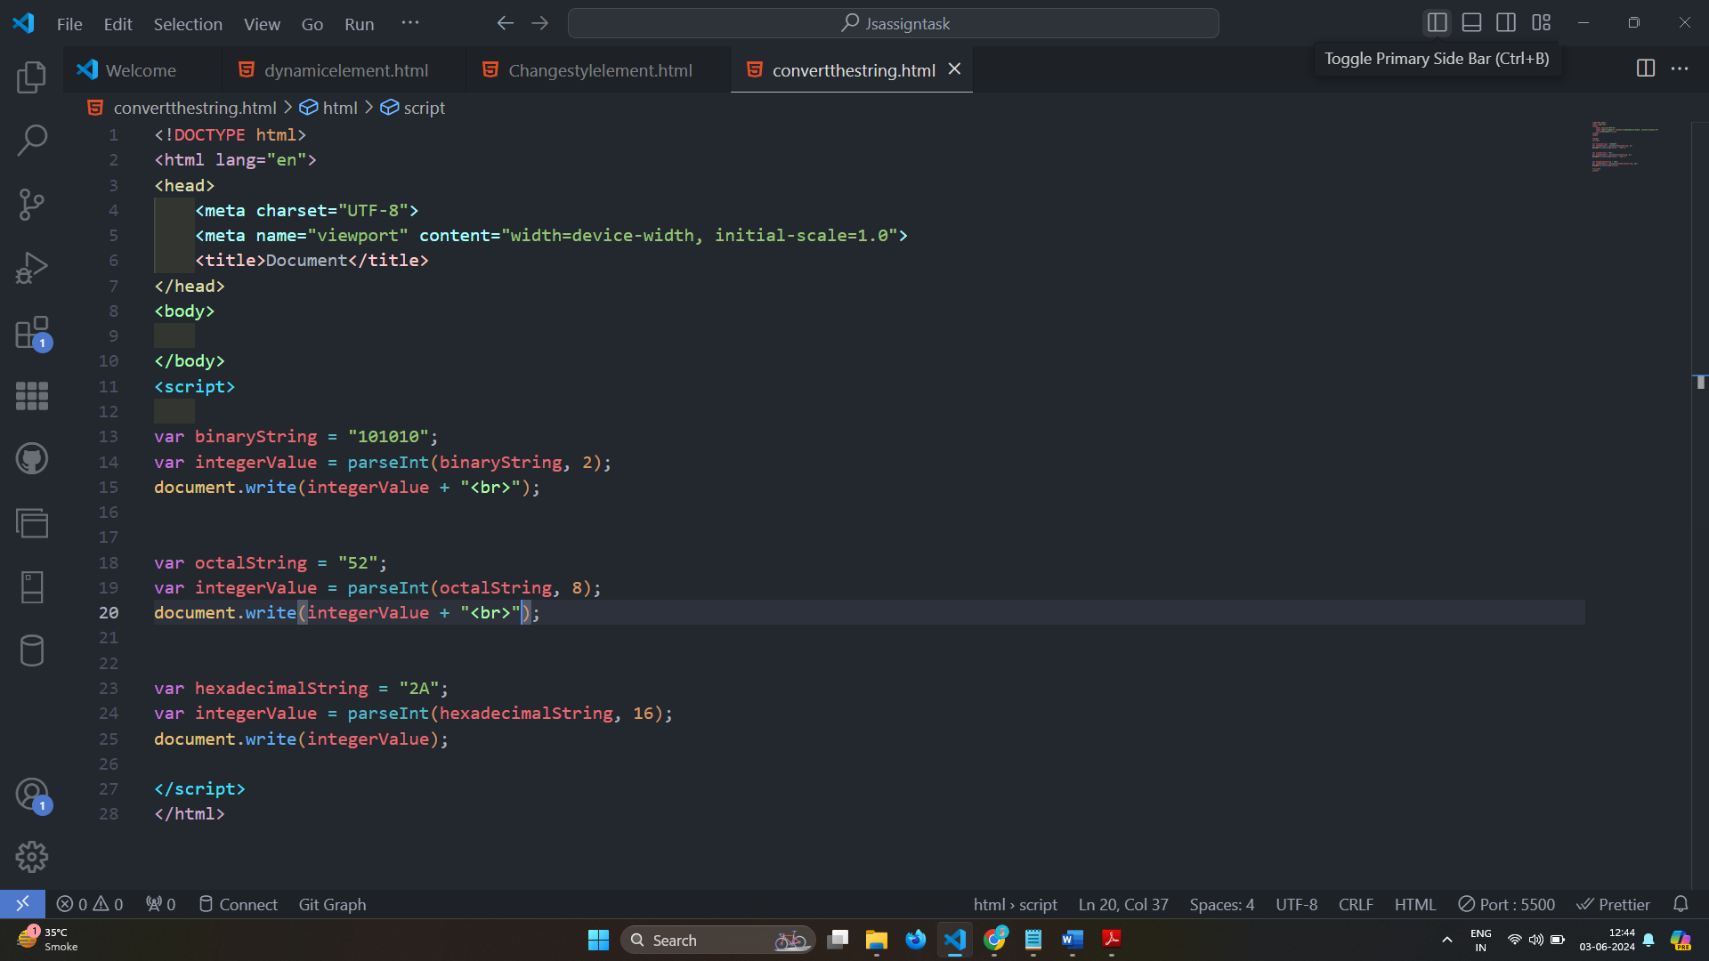

**Output:-**

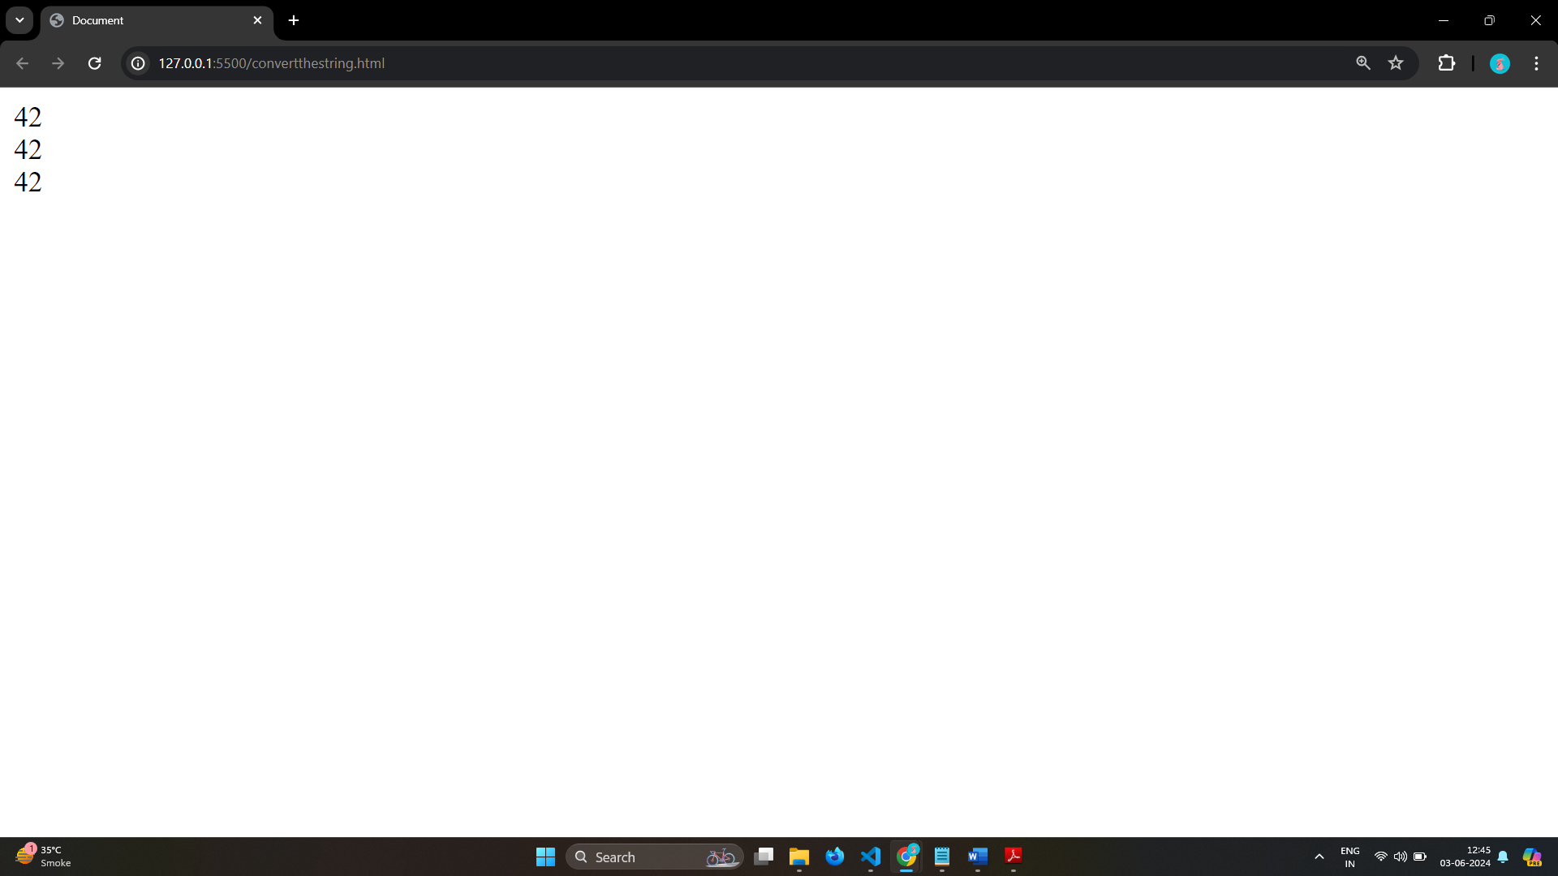

**• What is the function of the delete operator?**

**ANS.** The delete operator removes a property from an object. If the property's value is an object and there are no more references to the object, the object held by that property is eventually released automatically.

**• What are all the types of Pop up boxes available in JavaScript?**

**ANS.** : JavaScript has three kind of popup boxes:

1. Alert box
2. Confirm box
3. Prompt box.

Alert Box

Syntax

window.alert("sometext");

Confirm Box

Syntax

window.confirm("sometext");

Prompt Box

Syntax

window.prompt("sometext","defaultText");

**• What is the use of Void (0)?**

**ANS.** The void operator is used to evaluate an expression and returns the undefined.

This operator is used for obtaining the undefined primitive value.

It is often used with hyperlinks.

Usually the browser refreshes the page or loads a new page on clicking a link.

The javascript:void(0) can be used when we don't want to refresh or load a new page in the browser on clicking a hyperlink.

Syntax

void expression;

**• How can a page be forced to load another page in JavaScript?**

**ANS.** In JavaScript, we can use window.location object to force a page to load another page. We can use the location object to set the URL of a new page. There are different ways – window.location.href property, window.location.assign() and window.location.replace() methods, to set the URL of a new page using the location object. We will discuss each of the property and methods in detail in this tutorial.

**• What are the disadvantages of using innerHTML in JavaScript?**

**ANS.** innerHTML is very slow.

The event handlers do not get attached to the new elements created by setting innerHTML automatically.

Content is replaced everywhere.

Appending to innerHTML is not supported.

Old content replaced issue.

Can break the document.

Can also be used for Cross-site Scripting(XSS).

**• Create password field with show hide functionalities**

**ANS.**

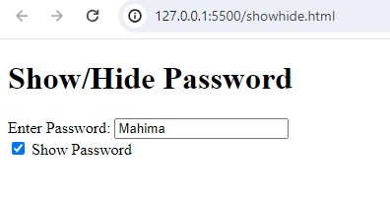

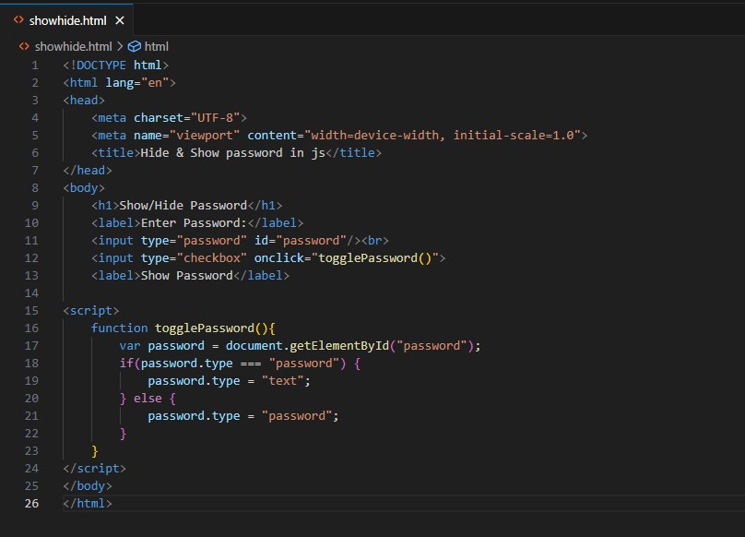

**• Create basic math operation in JS**

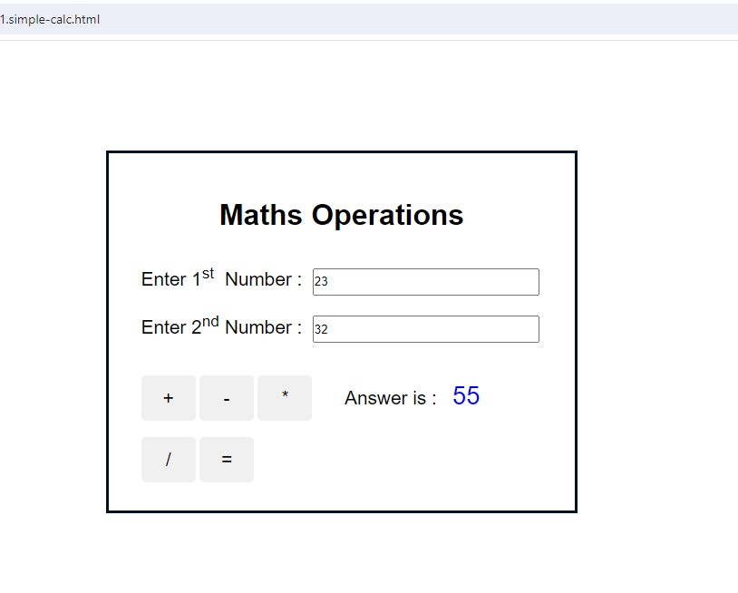

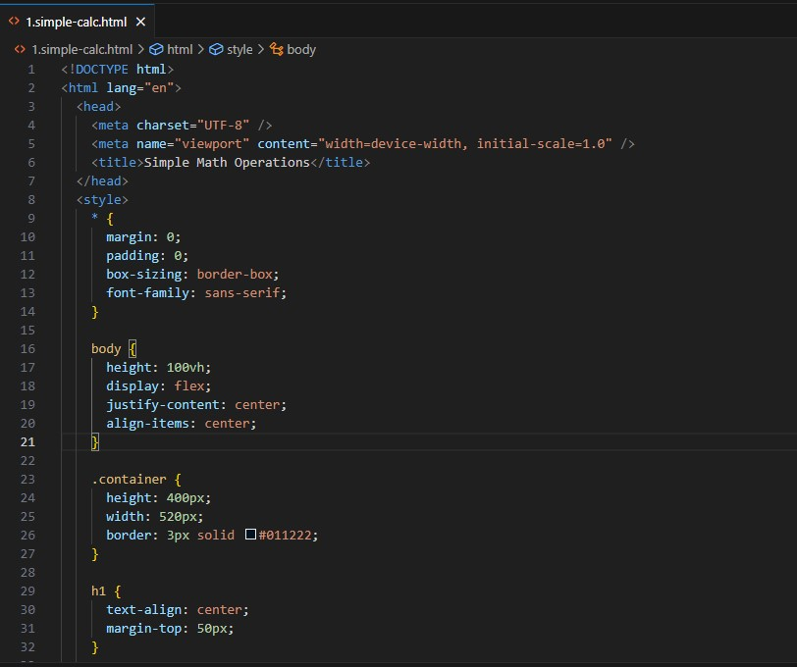

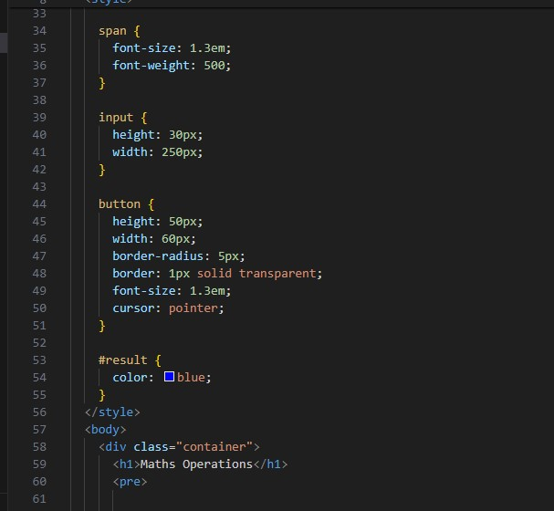

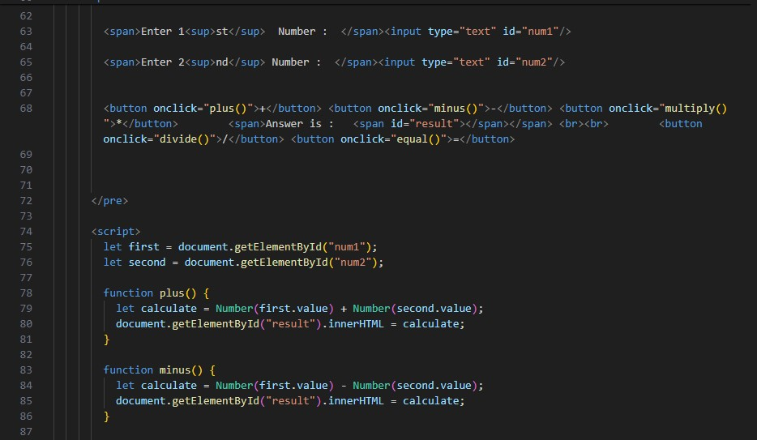

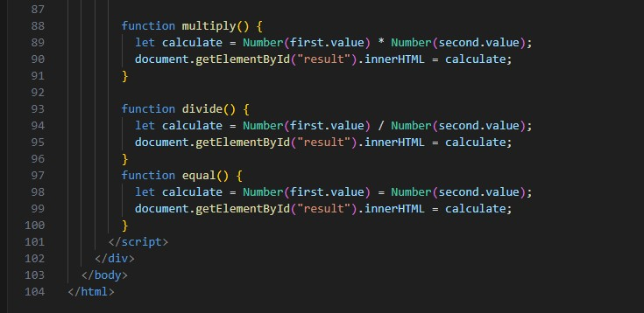

**• Create result**

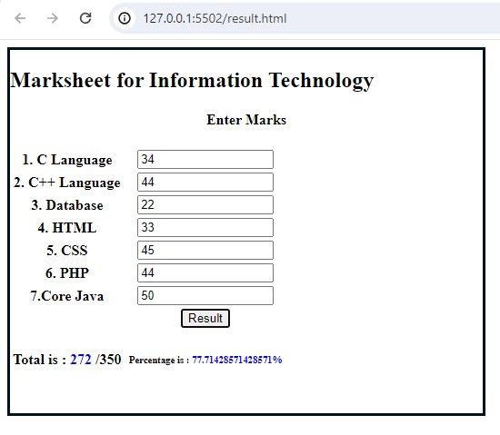

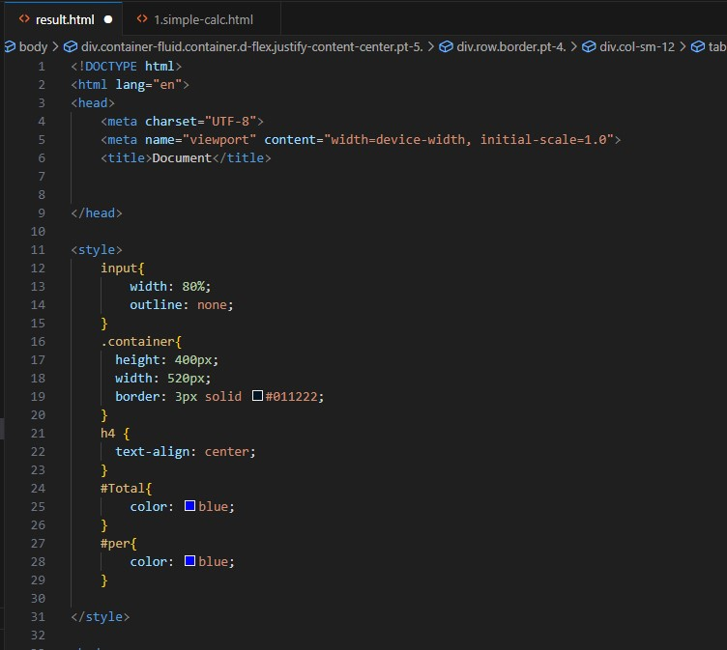

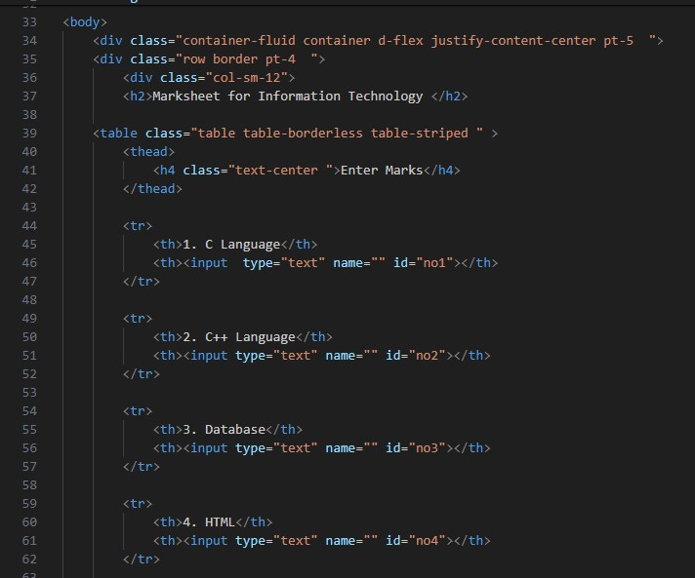

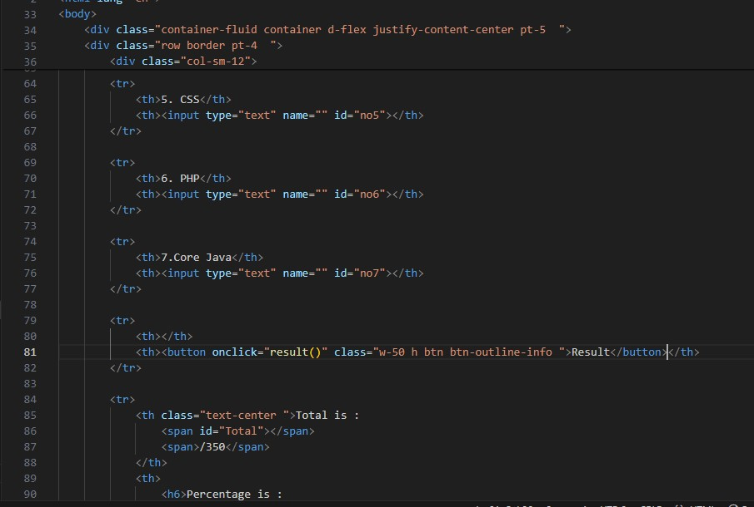

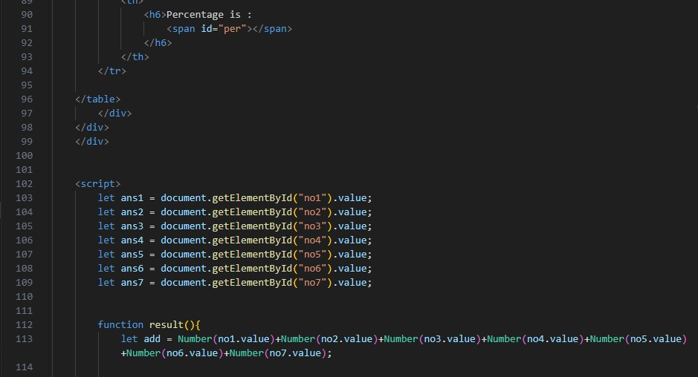

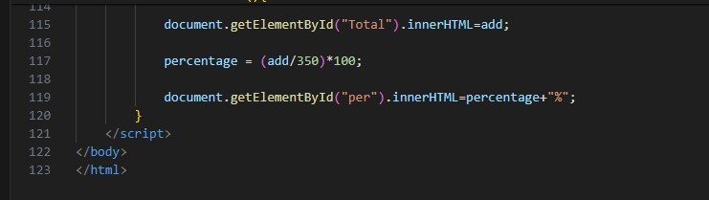

**• Create a slider using JavaScript**

